# https://my.london.ac.uk/image/company_logo?img_id=4997188&t=1687264528577

**Student Number**: 200342355

**Name and Surname**: Susanna Ventafridda

**Degree Title**:

BSc Computer Science

**Course/Module Title**: Computer Science Final Project

**Course/Module Code:** CM3070

**Date**: September 19th 2023

**Project Title:** GroupTripper – A web application to plan trips collaboratively

Table of Contents

 0

Introduction 4

Template chosen 4

Motivation for the project 4

Domain and users 4

Literature review – Market research 6

SWOT analysis 7

Design 8

Requirements and acceptance criteria 8

Use case diagrams 8

Prototypes 8

Technical infrastructure 8

Back-end 8

Front-end 10

API design 10

Data store design 10

Realtime web technologies 10

Monetization 11

Legal considerations 11

Search Engine Optimization 11

Evaluation plan 11

Development plan & timelines 11

Implementation 12

Entry point and Routers 12

Ajax calls 12

Hosting and Firestore database set-up 12

Authentication 12

Bootstrap 5 13

Input validation and sanitization 14

Database interactions and security 14

Realtime technologies 14

Useful libraries used 14

Evaluation 15

Whitebox testing - Unit tests 15

Blackbox testing 16

Vulnerability checks 16

User testing 16

Planning vs. execution evaluation 17

Conclusion 17

References 19

Appendix 26

Appendix A – Market research 26

A.1 – Competitors analysis summary 26

A.2 – Visual collection of competitors’ solutions 32

Appendix B – Functional requirements and acceptance criteria 63

Appendix C – Medium-fidelity prototypes 72

C.1 - First iteration 72

C.2 - Second iteration 76

C.3 - Third iteration 85

Appendix D – Email sending costs 90

Appendix E – Addresses autocomplete costs 91

Appendix F – Firestore collections design 92

F.1 – Users 92

F.2 - Trips 92

Appendix G – Payment platforms comparison 94

Appendix H – Features available with Pro subscription 94

Appendix I – UML Diagrams 95

Appendix J – Technical infrastructure 96

Appendix K – REST API 96

Appendix L – Timelines and Task Breakdown 97

L.1 – Gantt Chart 97

L.2 – Critical Path Analysis 99

L.3 Updated Gantt chart 99

Appendix M – SEO techniques 100

Appendix N – Feature prototype unit tests 102

N.1 package.json configurations 102

N.2 – unit tests folders 103

N.3 – Example unit tests for routes 104

N.4 Unit tests results 105

Appendix O – Feature prototype database interactions 106

O.1 – DB class: contains generic methods to interact with Firestore 106

O.2 – Sample queries 107

Appendix P – Feature prototype input validation and sanitization 108

P.1 - Front-end validation 108

P.2 – Backend sanitization 109

Appendix Q – Authentication 110

Q.1 – session creation API end point 110

Q.2 – Frontend Login call 111

Appendix R – GitHub repository and Git usage 112

R.1 - git log 112

R.2 – GitHub repository 113

Appendix S – Blackbox testing 113

Appendix T – Security scan results 121

T.1 results view – first scan 121

T.2 OpenVAS– first scan 122

T.3 Nmap – first scan 123

T.4 OWASP– first scan 124

T.5 – second scan 125

# Introduction

As a final project, I am going to build a collaboration web application that allows to plan and track trips as a group more effectively: GroupTripper.

With this project I want to demonstrate my ability to build a modern and secure web application that leverages cloud technology, integrates with third party APIs, optimizes SEO, and considers monetization strategies including hosting advertisements and allowing in-app payments via Stripe. By the end of this project, I want to have developed the POC of a product that could be launched successfully on the market and be a potential source of income. I am however aware of legal risks I could be subjected to by launching a business as a private individual and will thus take measures to ensure the product usage is restricted for the time being only to individuals who possess a private code.

## Template chosen

The template I have chosen is project Idea Title 2: A Collaboration web application, from CM3035 Advanced Web Development.

## Motivation for the project

Recent statistics about travel support the need for this application. According to TravelPerk [1], most American adults prefer booking their trips online, especially on their phones. Additionally, TravelPerk reports that travelers visit an average of 38 websites to complete and book their travel plans. Furthermore, TravelPerk highlights that the biggest frustration standing in the way of planning a trip is the need to compare different options.

The market has only recently started to address this need of adults to plan their own trips in a systematic and simpler way [4, 6] and hence there is an opportunity to enter this niche by offering a product that strategically bridges the gaps present in the existing solutions offered by the competition. I describe the details of my value proposition in the “Literature review – Market research” section of this report, which includes a SWOT analysis.

## Domain and users

GroupTripper aims to be the best social network application on the market that facilitates planning trips as a group online, minimizing the so called “analysis paralysis” associated with the planning process [1]. The idea of developing this app comes from the personal experience of planning trips as a group of friends. Everyone has different date preferences, people post different options on a chat. There is no systematic way to track these options, and the result is that it takes forever to decide. With GroupTripper, instead, users can enter personal date and destination preferences and find common availability. GroupTripper recognizes its users’ needs: having to compare different trip options and overcome the “analysis paralysis”. Users can prepare different trip options, assign research tasks to their friends, and let friends vote to facilitate decision making. This way, GroupTripper allows to complete trip plans faster.

I identify myself and my friends as target users for this application: young adults around the age of 30 who like to travel together and plan their trips in autonomy online. My assumption is reinforced by the audience demographics of existing main competitors: Wanderlog and Troupe [4, 6]. For Wanderlog, the majority of visitors belong to age group 25-34 (32.74%), followed by 35-44 (19.93%), followed by 18-24 (18.25%) [4]. Gender distribution is quite even, with a slight predominance of female users [4]. These trends are shown in Figure 1.



Figure 1 - Wanderlog audience demographics [4]

The same trends are confirmed by the audience demographics of Troupe.com reported in Figure 2.



Figure 2 - Troupe.com audience demographics [6]

# Literature review – Market research

It is important to analyze the existing online competition in order to develop a unique market proposition.

To identify potential competitors, I have used the following keywords searches in Google: “trip planning website”, “website for planning trips as a group”, “group trip planning”. Through these keywords I have also found an online article [2], mentioning some of the apps listed in appendix A.

In total, I have identified 10 competitors, listed in order of relevance in the table in Appendix A. The table contains a brief description of the product, as well as strengths and weaknesses, which I gathered after exploring each website. For each solution I noted what features I would like GroupTripper to have, as well as opportunities for improvement.

The most similar solution to my proposition is troupe.com [3], founded in the US in 2019, with 140k total visits in May 2023, coming from English-speaking countries, with most clientele in the age range 25-34 [4]. This is the only website I could find designed with the goal to facilitate planning trips as a group. Although it has some interesting features such as the possibility to do polls and vote on different proposals, the site’s design restrict user activities. Users can choose one date range, one destination, and one stay (no section for transportation), not allowing for a multi-destination trip. I plan to resolve these issues with GroupTripper. I also want to enlarge my customer base by making the site available in languages other than English.

The second-best trip planner website I found is Wanderlog [5], which has great planning features but no options to plan as a group. Wanderlog was also founded in the US in 2019, it has an annual revenue of 1-2M$, and 5.7 M total visits in May 2023 [6]. Wanderlog’s strengths are the integration with Google API used to log addresses and retrieve pictures for each added location, as well as its map features, which allow to visualize the itinerary and reorganize stops (route optimization is offered with their premium subscription). They also integrate with different third-party APIs to allow in-app booking of hotels, as well as proposing activities by location. Like Troupe, the app is only available in English.

The third best solution is Pilotplans, Canadian web tool with 352k total visits in May 2023 [7]. The tool is very similar to Wanderlog, offering a more intuitive way to create plans and a map view, as well as a live chat. However, it is not well-integrated with third-party APIs, it has no features to plan as a group, and it is also only in English.

Planify [8] stands out by offering the website in 6 different languages and by allowing to download the plan as a PDF. No statistics are available for this site. Planharmony [9] stands out by saving events in a calendar-looking fashion, which also allows to export plans to a preferred calendar. Finally, MiTravel [10] allows to organize trips on a Kanban board.

The rest of the tools listed in Appendix A were not available via web, as they either only offer mobile apps or they are university projects.

In conclusion, I plan to leverage many of the existing features offered by the established apps in this space. In particular, the ability to add different kinds of events (transportation, accommodation, activities, etc.) to a trip via a form, and eventually visualize the locations on a map (after MVP). Things that can be improved in this domain is the possibility to make plans as a group in an intuitive way, targeting a non-English-speaking customer base, as well as ensuring that a website is present and it allows to experience all features before committing to subscribe to GroupTripper. I personally experienced frustration when I tried to compare different tools and discovered that I couldn’t even try out the functionality because either they were available only for IOS, or available only for mobile with no website, or they requested payment right away.

## SWOT analysis

Having identified my competitors and analyzed their solutions, the following are the strengths, weaknesses, opportunities, and threats for GroupTripper.

|  |  |  |  |
| --- | --- | --- | --- |
| Strengths | Weaknesses | Opportunities | Threats |
| * Value of GroupTripper: a web tool that allows young travelers (23-35) to plan trips as a group. * Special functionalities:   + Polls   + Selective participation on plan items * Usage drivers:   + Preference for booking trips online [1]   + Analysis paralysis due to too many options [1]. Need to keep track of such options to compare and choose.   + Only one competitor offering ability to plan as group, poorly designed. | * Time and manpower limitations: only one person working on this project with a limited time span to deliver a working solution. * No funding to invest in advertisement to drive adoption of the tool, nor to pay for integration with external APIs (Google, TripAdvisor, etc.) * No prior experience in SEO, advertising techniques * No time to develop mobile apps | * Gain customer trust by providing free access to try out website functionality * Tap into non-English-speaking markets * Offer a more user friendly experience than the only other tool available to plan trips as a group, by leveraging what works well from other existing products and adding collaborative features * Rank high in Google searches by leveraging SEO and good domain name * Leveraging available statistics on existing tools to save on advertising (consistent age groups: 25-25, 18-24, 35-44) * All competitors are new, started after 2019 | * GroupTripper’s competitors are relatively new, but already have a significant customer base. Additionally, they can leverage startup funding. They are linked in blog posts and they advertise on social media channels. It will be difficult to enter the market. Large investments in advertisement might be necessary |

In summary, although there exist web trip planning tools such as Wanderlog, which already count on 6 million monthly views, only one tool exists offering the possibility to plan as a group: Troupe, with only 140k monthly views and serious design limitations. With GroupTripper I intend to bridge Troupe’s limitations and establish as a leader solution in the space of online tools to plan trips as a group. With no funding and time constraints it will be challenging to provide functionality such as API integration, map views, and payment integration. Lack of funding will also limit advertising capabilities, forcing us to purely rely on SEO to rank high on Google search. I will need to research SEO techniques as I have no experience in this. However, I am confident I will set up an MVP outperforming Troupe and that I will be able to successfully further expand on the product adding increasing functionality after launch.

# Design

## Requirements and acceptance criteria

In order for GroupTripper to become the leading web tool to plan trips as a group, I defined a list of functional requirements and acceptance criteria based on the market research and SWOT analysis reported above. The table in Appendix B reports the features I plan to implement within GroupTripper’s MVP and it describes the goal, user story, requirement, and priority of each feature. Features with high priority constitute the acceptance criteria for the MVP.

## Use case diagrams

Appendix I contains three UML use-case diagrams to display the behavior of GroupTripper in relation to its three types of users: authenticated new users, unauthenticated users that already have an account, and unauthenticated ones.

## Prototypes

I followed an iterative approach to design the prototypes. Starting from the functional requirements (with high priority i.e. success criteria for MVP) reported in Appendix B, I have drafted a first series of medium-fidelity prototypes, which are displayed in Appendix C.1. I then refined these prototypes (Appendix C.2), created a Google Forms survey [11] and shared the second iteration prototypes with a group of friends that represent the target audience of GroupTripper, in order to get feedback and recommendations. Although I only received 2 responses, I managed to incorporate those recommendations into the third iteration of the prototypes that are shown in appendix C.3. I decided not to create high fidelity prototypes for this project, due to time constraint and because in my opinion medium-fidelity ones are enough to reference in the implementation phase and are thus a sufficient time-effective effort. Instead, it takes a lot more time to develop high-fidelity prototypes and due to limitations of the most popular software to produce them – Figma – it is not possible to translate design into HTML and CSS automatically without paying. I have no budget dedicated to developing this product and hence creating detailed designs on Figma would only mean having to spend double time on designing an esthetically pleasing UI (before replicating the effort with HTML and CSS). Medium-fidelity prototypes ensure that all functionality has been thought of. As for esthetics, I plan to make the website as simple as possible prioritizing accessibility constraints. Light minimalistic background, with properly contrasted dark text. You can find more details on this in the Front-End section of this report below.

## Technical infrastructure

### Back-end

When it comes to choosing how to deploy a REST API or web app there are multiple options to be weighted based on one’s priorities. My priorities are: first, I want to be able to deploy my application fast, without having to take care of servers and networking configurations, and without having to take care of scaling up resources manually when the user base grows. Second, I want to do so in the cheapest way possible. Finally, the infrastructure needs to be able to accommodate the features that my app requires.

There are different cloud services available, which ensure scalability and require different degrees of manual configurations to do. I will compare Baas and IaaS solutions and explain why I ultimately chose BaaS.

#### BaaS - Google vs AWS

“Backend as a Service (BaaS) is […] a modern cloud computing type that is useful to build mobile applications rapidly. Startups, SMEs and large enterprises prefer to go with BaaS solutions because of their low cost, speedy development and other benefits.” [12].

Two common BaaS solutions in 2023 are Firebase (Google) and Amplify (AWS) [12]. These are both “excellent choices for serverless architecture apps in Web Development”[19].

AWS Amplify facilitates back-end and front-end development and offers web hosting for free for a year, then pay as you go based on resources consumption [13]. The main differences between Amplify and Firebase “rely on the database implementation, APIs protocols, and cloud services each platform runs on top”[17]. ”Amplify is more complicated and has a higher learning curve than Firebase. It also needs additional setup and tuning.” [14]. This makes Firebase more ideal for small projects where time to market is critical [18]. Firebase offers an unlimited free tier [16, 20], as well as free easy authentication integrating with third-party services (Google, Facebook etc.) [15].

Given the above information, Firebase seems more suited to the requirements of this project and it is therefore my preferred choice over Amplify.

#### BaaS vs. IaaS

“Infrastructure as a service, or IaaS, delivers on-demand infrastructure resources to organizations via the cloud, such as compute, storage, networking, and virtualization. Customers don’t have to manage, maintain, or update their own data center infrastructure, but are responsible for the operating system, middleware, virtual machines, and any apps or data.” [21]. App engine is Google’s IaaS [21], while AWS offers equivalent services with Beanstalk [23, 24], although at a slightly higher price [28].

Essentially, the main difference between Firebase and App Engine is the lack or presence of a backend respectively [22]. For example, with App Engine one can deploy applications built with frameworks such as Django and decide to set up complex architectures to handle custom data storage and processing solutions (NoSQL vs. relational vs. Data lake, batch vs. streaming). Example of companies using App Engine are Snapchat and Dialpad (enterprise cloud phone system), both needing to process big data (streaming, large amount, unstructured data) [25].

On the other hand, Firebase is used by companies such as Alibaba, The New York Times, The Economist [26], Lyft, Duolingo, and Venmo [27], where data processing is more straightforward. Google App Engine offers standard and flexible plans [29], the flexible plan allowing for WebSockets and demanding at least 1 server stays working at all times.

#### Does GroupTripper require a complex back-end solution?

The only use case for my application to require a backend beyond a NoSQL database is if I wanted to build live chat functionality. Although this is one of the requested items within the project template to get full marks, I am not sure it makes sense to stretch my requirements and set up a more expensive infrastructure [30] to implement a feature that is actually not necessary for my application (and which you can check I have already correctly implemented in the Advanced Web Development final project [31]). While building an API with a framework like Django is faster than writing all the backend logic manually [34], the time saved in configuring the backend justifies in my view going with Node.js and Firebase, as reinforced by many views on a related Quora post [35]. Having to write each database call as opposed to using Django’s ORM also comes with flexibility [34]. As for security, we can follow best practices to minimize the risks to incur cross-site scripting, cross-site forgery requests, code injections, and other common attacks [32, 33].

#### The chosen solution

Appendix J displays the technical diagram of my chosen solution. I will use Firebase to host the website, leveraging Firebase authentication, and the No-SQL Firestore database (no real-time needed). I will use cloud functions to store the application code, which will be written in JavaScript using Express: “a minimal and flexible Node.js web application framework that provides a robust set of features for web and mobile applications.” [36]. I will also make use of Ajax to make asynchronous calls to the Firestore database [40] for certain features. Finally, I will need to send emails to users requesting to sign up or to send them notifications. To do this, I will explore solutions mentioned on StackOverflow [41], which reference an official Firebase Github solution to send confirmation emails with different email sending platforms [42]. Appendix D contains a price comparison of different email platforms. I chose to use Google’s SendGrid as it’s the cheapest. In order to allow users to select places with autocomplete from a drop-down menu when creating itineraries, I have compared different options and their pricing in appendix E and decided to use MapQuest [57].

### Front-end

For the front-end I am going to use Bootstrap components and EJS templating. I will use palettes with accessible color contrast [37] and test color accessibility using Wave [39] once my website is hosted, following color accessibility best practices [38].

### API design

Appendix K displays the REST API end points I designed, which leverage HTTP methods supported by all modern browsers [43] and follows REST API design best practices [48]. The implementation of these calls is closely related to the considerations reported in the Data store design section. I will use content negotiation to have each end point accept / return JSON or HTML, in order to improve SEO [52].

### Data store design

“When using Firestore, the mechanism for billing is related to the number of reads, writes, and deletes we perform.” [44]. Therefore, I will design my solution in a way such as to minimize reading and writing, while considering Firebase architecture [46] limits e.g. maximum size for a document is 1MiB [45]. I will also have my application maximize caching database queries where it makes sense [47]. Appendix F contains the design for the two Firestore collections I will create: “users” and “trips”, done considering data types available in Firestore [58]. Documents will be updated using Firestore transactions [59]. Database permissions will be set using Firestore security rules [60].

### Realtime web technologies

I plan to use Firebase snapshot listeners on the client side, to ensure database updates are received in a real-time fashion by all users [120, 117, 119]. This is an alternative technology to Web sockets, which is explained in detail on Google’s documentation [116].

## Monetization

I plan to have a free app version and a Pro subscription version. The free app version will use Google Adsense [64] to cover what I expect to be minimal infrastructure costs. Users will be able to switch to the Pro version by paying 5.99 € per month (automatically renewed) via an integrated payment method on the website. Appendix G displays a comparison of 2 Payment platforms: Stripe and Square. I chose to use Stripe due to same pricing as Square but more included support. Appendix H shows the features that will be available only with a Pro subscription.

## Legal considerations

I plan to consider legal obligations under privacy, consumer protection, copyright, and defamation law [72].

## Search Engine Optimization

I intend to follow SEO best practices such as choosing a meaningful domain name, using the right keywords (repeated at the top of the page [74]), ensuring all links from my website work [73]. Appendix M contains a full list of SEO techniques I am going to use.

## Evaluation plan

In order to ensure I develop a successful and functioning application, I will:

1. Implement Unit tests with good test coverage (white box testing) using Node.js Test runner [110] and node-mocks-http [112].
2. Black box testing: I will ensure that all functionality listed as acceptance criteria (Appendix B, priority high) works as expected, manually.
3. Run vulnerability checks on my live application using two or more web security scanners [70, 71].
4. User testing: after the MVP is ready, I will invite people to test it and ask to answer a questionnaire that will include questions recommended by usability testing experts [69]. I plan to get at least 20 responses to this questionnaire.

## Development plan & timelines

Appendix L.1 shows a Gantt chart containing a detailed description of milestones, tasks, and timelines, which I plan to follow in order to complete this project on time. Milestones include infrastructure setup, security aspects, pages development, and report writing. Hard deadlines are shown in red. Orange tasks are yet to be implemented, green tasks are those that have been completed, yellow means in progress. I plan to update this chart every week. I have assigned timelines to milestones and assigned a period of one week to most milestones, depending on the complexity of the tasks within. I will work in an Agile fashion, with sprint periods of one week. Each week I plan to work on the assigned tasks and reassess priorities as I go along in case I encounter unforeseen difficulties and need to alter the work plan, or conversely in the optimistic case in which I progress faster than expected. I do consider these to be realistic timelines, based on similar work I have completed in about the same amount of time for other classes of this degree (Advanced Web Development, Web Development, Agile Software Projects) and my progress so far. Appendix L.2 contains a critical path analysis table, which references each milestone of the Gantt chart and indicates each milestone’s dependency. For example, we can see that milestone 3 (authentication) can only be started once milestone 2 (infrastructure setup) is complete and it will take 9 days of development.

# Implementation

GroupTripper is a web application that requires users to register accounts to start collaborating on the platform in creating trip plans. As such, the most important features are: setting up the infrastructure, including database and hosting, setting up a secure authentication mechanism, ensuring that the front-end can effectively communicate with the backend, saving and retrieving information to/from the Firestore database with appropriate API calls, ensuring the correct behavior of routers via unit tests, ensuring that users can communicate in real-time, ensuring that appropriate permission rules are implemented to control user access to the database, and finally that all features mentioned in appendix S are implemented and function correctly. I have implemented all the above and my website is accessible at <https://grouptripper-3c7f1.web.app/> . Currently, registration required a beta test code: “girotondo”. For the moment I am not allowing Google to index the website [105]. Once the product is fully ready, I will remove the “<meta name="robots" content="noindex, nofollow" />” from /functions/views/partials/sharedHead.ejs

Figure 3 - GroupTripper logo, made with Inkscape [81, 82, 83].

I have designed the website logo (Figure 3) with Inkscape by following a few Youtube tutorials [81, 82, 83]. The project is stored in a public Github repository [122]. Appendix R further proves usage of Git.

## Entry point and Routers

The entry point of the application is functions/index.js [142]. Here, Firebase is initialized and Express [36] is also initialized. At lines 72-79 all the routers are called, enabling users to call 8 main routes, with additional paths and relative HTTP request methods specified in the routers themselves. Each router logic is specified in a dedicated file [143]. For example, the settings router [144] defines 2 API end points: GET /settings and POST /settings. When a request returns status code 404, a dedicated page is rendered – implemented in index.js, lines 81-96 [142]. Routers can check whether users are authenticated and display information accordingly. They can interact with the Admin SDK and connect to the database, then use this content to fill EJS templates that are returned to clients. For example, the settings router end point GET /settings checks that users are authenticated at line 19, then interacts with the database at line 20 to get or create user settings, and finally renders a template filled with the information retrieved from the database at line 31 [144].

## Ajax calls

Some of the API endpoints are called from the frontend via Ajax calls. An example of this can be seen when users want to delete a poll. Within tripPolls.js [145], line 324, I define that when the user clicks on the “delete poll” button, they are prompted with a pop-up asking to confirm the poll deletion. If the user confirms, function deletePoll is called. The function is defined at line 138 [145] and it contains an Ajax call to /trips/<trip ID>/polls/<event ID> with method DELETE, which has the effect of deleting the poll from the database.

## Hosting and Firestore database set-up

To set up hosting and Firestore database, I have followed the instructions to set up web projects on Google’s documentation [84]. However, this was not a straightforward process, as I had a few issues related to the cloud region as well as errors thrown by the Firebase CLI during set up, so I’ve had to repeat the process manually a couple of times before everything worked. I have documented all the set-up steps within my Github repository’s “DEVELOPMENT.md” file, located at the root of the project.

## Authentication

By far the hardest feature to implement so far has been authentication. My application consists of a Node.js backend API, which fills EJS templates upon request and sends them to clients, and a simple JS + HTML + CSS front-end from which clients make HTTP requests and navigate to different pages, being served different content. Mine is thus not a single page application, although in some instances, API endpoints are called in the background with AJAX calls (e.g. saving notification setting when user clicks on toggle on the UI).

I initially implemented authentication using Firebase client SDK for the web [85] instructions. This was quite straightforward. However, when it came to test the application I soon realized I was being asked to login at almost all page refreshes. Clearly something was wrong.

I then looked into how to persist user authentication [86] and tried to implement the proposed solution. However, HTTP requests started to time out. I initially tried to implement manual ways to persist authentication on the backend with Node [87], but that seemed like a very unsafe and hackey method to me. It worked, but it meant saving users authentication on local files on the server.

A this point I was a bit anxious that I would not be able to meet the deadlines, not being sure I’d manage to find a solution. I continued searching and found out that Google Firebase actually has 2 SDKs: client and admin. I found that the proper way [88, 91, 92, 93] to implement authentication in this front-end + backend scenario with Firebase is to use client SDK on the front-end, set up session cookies and have the backend enabling and validating sessions via the admin SDK. Users must log-in i.e. initiate sessions from the front-end using the client SDK [89, 95]. When the user logs in, they send an HTTP POST request to the /auth/sessionLogin end point. This request is prepared by the client SDK and it contains an ID token [90], as well as a crsfToken. Upon receiving this request, the back-end’s admin SDK verifies the ID token and creates a session cookie that will be valid for the next 8 hours (my custom implementation) [94]. The session cookie is attached to the request response and returned to the client that way. At this point, all subsequent client requests will contain the session cookie. The back-end verified the integrity of all requests by checking such session cookie to determine what user is currently logged in and to display/return content accordingly. While some API calls don’t require user authentication, others require to return data that only one specific user can have access to.

At this point everything seemed to work when running the application on localhost with the Firebase emulator [96]. However, once I deployed the app to the cloud, suddenly sessions were not working. Upon further deep diving on the issue, I found that when running on Firebase hosting, cookies can only be stored under the name of “__session” [97]. “When using Firebase Hosting together with Cloud Functions or Cloud Run, cookies are generally stripped from incoming requests. This is necessary to allow for efficient CDN cache behavior. Only the specially-named __session cookie is permitted to pass through to the execution of your app.” [97]. Finally, authentication did work as expected. Snippets of authentication implementation are available in appendix Q.

### Bootstrap 5

The process of authentication is one of the many occasions in which I like to display HTTP request responses to users, to communicate with user-friendly messages the outcome of users’ actions.

The front-end is implemented in vanilla JS, with EJS templates being rendered to HTML with CSS. I make use of Bootstrap 5 [99] to quickly create modals, navigation bar components, buttons etc. One minor issue I stumbled upon is the difference between bootstrap 4 and Bootstrap 5 when it comes to implementing certain functionality like modals. In particular, I’ve experienced the issue that modals would not work. Once aware of this difference, the problem was straightforward to fix: I just needed to modify a few HTML attributes for the modals to work [100].

I also used one of Bootstrap5’s login forms [101] to display during the login, signup, and password reset phases.

### Input validation and sanitization

On the font-end, input validation is enforced making use of regular expressions and other checks. Custom error messages are displayed to users explaining required rules (/functions/views/authentication.ejs in the repository) [102]. On the backend, I found [103] that Express comes with its Express-validator [104] module so I decided to use this. An example of sanitization can be found in /functions/routers/authentication.js at the beginning of the POST /signup method. Appendix P contains examples of input validation and sanitization implementations.

## Database interactions and security

API calls are handled on the backend, making mixed use of client and admin SDK. All calls that require user authentication are handled via admin SDK, which uses secret credentials stored as configuration file in the repository. After the evaluation of this project is concluded, I will rotate credentials and make the repository private or find another way to sore this sensitive information. Calls made with the client SDK, on the other hand, leverage other configurations keys, which can be made public to users. Clients make calls using the Firebase SDK when they need to login and start a session (constraint explained above), as well as when real-time communication is required. Access to the Firebase database is controlled by security rules [106]. The security rules currently implemented are available in the repository [129] and ensure that users can access only data that is relevant to them, as demonstrated in a dedicated article [118].

Most database interactions are handled by the admin SDK on the back-end, ensuring that users are authenticated (session cookies, explained above). I have implemented all required operations and queries to create and interact with two collections: users and trips, described in Appendix F. Basic operation [130] and specific queries [131] are implemented within the repository in /functions/db/ and are also shown in Appendix O.

### Realtime technologies

The web development collaboration web application template mentions that outstanding student projects should make use of realtime web technologies such as Websockets.

Manually implementing Websockets is not recommended / supported with Firebase projects [113]. The supported alternative that implements websockets is to use the Firebase realtime database [114], which can be however quite expensive [115]. However, upon further investigation it turns out [116] that even the standard Firestore database allows near-to-real-time (low-latency) querying at a lower price. “Real-time queries, also called snapshot listeners, let the app listen to changes in the database and get low-latency notifications as soon as the data changes. An app can get the same result by periodically polling the database for updates, but it's often slower, more expensive, and requires more code.” [116]. I have implemented real-time functionality in my application in order for users to comment on plans and polls, see new plan updates, and receive notifications in real-time. To implement these functionalities, I have therefore implemented snapshot listeners on the client side, to ensure updates are received in a real-time fashion by all users [120, 117, 119]. For details of how snapshot listeners work, you can reference Google’s documentation [116]. For example, a snapshot listener is implemented to get poll events in real-time from the application front-end [132].

## Useful libraries used

In order to let users upload and resize their profile picture, I used Croppie [134, 135, 136]. Profile pictures are directly saved as base64 encoded strings in Firestore [137, 138]. To implement searchable select menus with custom options I leveraged the Tom-select JS library [139, 140]. I used these for example to let trip owners choose who they can add to a trip poll, pre-populating the menu only with the user’s friends [141].

# Evaluation

I implemented all features I planned to implement in my Gantt except 2 ones (Google Adsense and payment integration with Stripe). All functional requirements specified in Appendix B with Priority ‘High’ i.e. all acceptance criteria defined in the planning section of this report are complete. I am overall satisfied with the implementation. I have done all that was in my power, given the time constraints, to insist on reasonably high standards during the research, design, and implementation phases. My application is serverless (thus scalable) and secure (session cookies, Firebase hosting with zero-configuration SSL [121], database rules correctly configured). All routes implemented have unit tests and behave correctly.

I also implemented real-time updates for clients (e.g. notifications are received by all relevant clients the moment they are sent). To do this, I leveraged Firebase Snaphot listeners [116]. The implementation of Snapshot listeners is proprietary to Google, but it seems [128] that the technology behind it is an implementation of the WebSocket protocol, which defaults to long polling when the first option is not supported by the browser. Plausibly, the client opens a WebSocket channel to the Firebase server and communicates live updates through it. Due to time constraints some aspects of my implementation of real-time updates could be improved. For example, when multiple users comment on the same event in a trip and a new comment is posted, the comments section is closed automatically (and its content updated). The user has to reopen the section to see the update. I plan to implement a better implementation for these type of features after the MVP launch.

As described in the design section of this report, my formal evaluation plan comprises 4 steps: unit tests, black box testing, security, and usability testing. The following sections cover these points.

## Whitebox testing - Unit tests

Before this moment I had never implemented unit tests in JavaScript. I did some research and the most common libraries to write unit tests in JS seem to be Mocha and Jest [108]. I later found out [109] that in 2022 Node.js implemented their own integrated testing framework: Node.js test runner [110, 111]. I decided to use Node.js test runner in combination with node-mocks-http, a library to test Express routing functions [112]. I eventually managed to correctly set up tests folders and package.json. Unit tests can now be run with the `npm test` command, from the project root folder. Unit tests configurations, examples, and outputs are available in Appendix N. The first picture in appendix N.1 shows the configurations needed to run `npm test`, while the second figure in appendix N.1 shows the required dependency node-mocks-http. The image in appendix N.2 shows that the folder structure of the tests mirrors the folder structure of the project. For each router there is a test folder containing related unit tests. I have implemented unit tests also for two utils functions: authentication and time. The image in appendix N.3 shows an example of unit test for the home router. Here, the first unit test check that when a user is logged in, visiting the “/” route redirects them to the /trips page. The real behavior of the routers in this application is that a function called verifySessionCookie is called to ensure that the user who makes a request has a valid session i.e. decrypts session cookies and returns user session information (who is logged in, since when, etc.). To mimic user authentication, function verifySessionCookie is mocked, returning fake user-related details (l. 13). At line 31, a mock GET request is emulated, containing cookies with the “__session” field. When the response event ends, lines 41 to 47 check that the response status code is 302 (redirect code), and that when redirecting the session cookies are passed along. Unit tests cover all scenarios possible in the routes logic and have a very similar structure throughout the code. Appendix N.4 shows the results of the unit tests: all 23 tests pass. Although all routes have unit tests, unit tests coverage could be increased and the existing unit tests could also be more detailed. Due to time constraints I was not able to precisely mock all database interactions and only tested the generic functionality of routers such as status codes, rendering, and redirects.

## Blackbox testing

In order to ensure that all the website functionality behaves as expected, I have thoroughly performed all operations that users will perform and checked that they work correctly. In appendix S, I report a comprehensive list of all features implemented. This corresponds to the list of functional requirements specified in Appendix B with Priority ‘High’, which is the list of acceptance criteria defined in the planning section of this report. I describe the testing procedure followed, as well as the test results (pass / fail). All acceptance criteria are correctly implemented and thus all tests until feature 21 pass. Due to time constraints I was not able to implement features 22 to 24.

## Vulnerability checks

As mentioned in the Design - Evaluation plan section, I have referred to Kumar [2023]’s third option – i.e. <https://hostedscan.com/> to scan my website for security vulnerabilities. This in turn leverages OpenVas, Owasp_ZAP, and Nmap. OpenVas is “one of the recent and popular open-source tools providing vulnerability scanning and vulnerability management options.” [71]. “The scanning engine of the tool is regularly updated with the Network Vulnerability tests.” [71] and “The tool is equipped with identifying security issues in the network servers and devices.” [71]. In 14 minutes, Hostedscan.com [123] completed the checks. All resulting reports in HTML format are available within Appendix T. The first scanning found 5 medium-security risks and 9 low ones.

One of the reported vulnerabilities regarded setting the correct cross-origin-resource policy, so that the session cookies, which contain confidential information, are not sent to third party-sites. I was able to solve this by implementing [a small change to fix a syntax error](https://github.com/SusyVenta/UniFinalProject/commit/08fbb7a06dfdf9bc5c8f41eac9a2da49cc49dd07#diff-80cdfa2758e436ab76ba448b17f5eb7a4fd7ac02a05cd21ec07905b67b869f3e) [124] for all pages that require authentication. Personally, I consider the clearest report to be the one generated by the OWASP scanner, which classifies vulnerabilities by severity and explains in simple words, well-formatted what is the issue. Unfortunately, although I have tried to resolve more issues related to headers by using the helmet library [125] as suggested by Edwin [126], a second scan gave more or less the same results (only 2 solved risks), as shows in Appendix T.5. Additionally, by addressing security vulnerabilities, some of the functionality of the website stopped working, so I have had to roll back security-related changes. Due to time constraints, I will leave the resolution of these risks to be addressed as future improvement, after launching this MVP.

## User testing

I have created a [survey](https://forms.gle/jZn5BEFNrhS4bb8k6) with Google Forms to evaluate GroupTripper’s usability, referencing 7 of the questions recommended by UX-design experts [69]. I shared this survey via Email with 20 people (work colleagues and friends corresponding to the target demographic (25-34 year old [4, 6]). Responses highlighted some bugs and improvement suggestions which I report in Table 1.

Table 1 - Bug report and improvement suggestions

|  |  |
| --- | --- |
| N. | Suggestion / Issue |
| 1 | From mobile, when no notifications present, the menu still presents an empty list |
| 2 | When signing up, the username field does not accept numbers |
| 3 | The email that is sent confirming user registration does not contain a link to directly go back to login |
| 4 | Trip common dates availabilities are not visible enough. They should be highlighted |
| 5 | From mobile, when navigating backwards in pages, bugs emerge in the process of adding friends to trips |
| 6 | When the owner of a trip finalizes common dates, all trip members should be notified. |
| 7 | Make it clear what fields are mandatory to fill in forms by marking them with a star |
| 8 | Don’t notify self when creating an event |
| 9 | Notify trip owner when all participants decide whether to join the trip or not |
| 10 | Bug when seeing comments – need to click twice |
| 11 | Notify event owner when a comment is added |
| 12 | From mobile: notifications settings events are fired even if a user scrolls and to do so clicks on the row where a switch is present. Events should only be fired when users click exactly on the notification setting switch (stop event propagation). |
| 13 | Password form in login and signup should have an ‘eye’ icon on the side that allows to briefly display it. |

Unfortunately, due to time constraints, I cannot address these items before the submission for this assignment. I do, however, plan to address them at a later stage so that my website can be used comfortably by all users, including myself.

## Planning vs. execution evaluation

As mentioned in the black box testing session above, I could implement all main functionality for GroupTripper as defined in the planning phase of the project. However, due to time constraints I could not tackle some of the challenging features I wanted to explore. Namely, in the initial Gantt chart displayed in Appendix L.1 I planned to dedicate time to integrate Google Adsense and Stripe for payments. Unfortunately, implementing the main functionality took longer than originally planned, so I will integrate advertisement and payments at a later stage. I have also had to rearrange the order of implementation of the existing features, as the initial critical path analysis turned out to be inaccurate. I realized during the implementation that, for example, in order to implement the trip participants page, I first needed to implement user profiles and the friendship model. Only then any user could add other users to a trip. I thus altered the original Gantt chart to reflect the actual progress I made until completion. This is available in Appendix L.3.

# Conclusion

The objective of my final project was to build a collaboration web application that allows to plan and track trips as a group more effectively: GroupTripper. I wanted to demonstrate my ability to build a modern and secure web application that leverages cloud technology, integrates with third party APIs, optimizes SEO, and considers monetization strategies including hosting advertisements and allowing in-app payments via Stripe. I wanted to developed a POC of a product that could be launched successfully on the market and be a potential source of income, offering a better user experience than that offered by my major competitor already on the market: Troupe [3].

I have only partially succeeded in achieving my original objectives: I have developed a fully functional POC for GroupTripper, deployed and available at <https://grouptripper-3c7f1.web.app> . Based on the results of my security tests, the application is secure (no high risks reported). I used Google cloud technologies to implement the website’s back-end as well as for hosting. I have integrated a third-party API, Pexels, to dynamically associate pictures to trip titles, I have implemented SEO considerations (currently the site is not indexed by search engines as I want it to be only when fully ready to use), and it integrates all main functionality offered by Troupe and that I planned to implement for the POC. Although I have thoroughly considered monetization strategies in the planning phase, due to time constraints I was not able to implement this aspect.

The application currently allows users in possession of a beta test code to correctly register to the website and collaborate in real time on the creation of trips.

Much development work is still required before this product can be successfully launched on the market. First, all bugs reported so far need to be solved, and further usability testing needs to be carried out especially on mobile devices. Second, database interactions can be optimized to reduce calls to the minimum in order to avoid spikes in costs once many users actively interact with the product. Database queries also need to be refactored and rewritten as transactions [133] as currently sequences of operations can’t be performed as a unit. This is a crucial consideration that needs to be addressed before implementing payment features. More time needs to be dedicated to solving all security concerns highlighted by the security reports, and unit tests need to be expanded to thoroughly comprise interactions with databases and details of template rendering. Real-time update features need to be improved so as not to disrupt user activities already in progress (e.g. if a user is writing a comment and another user posts an update, currently the comments section gets closed and the active user needs to restart writing the comment from scratch).

Before launch, I would need to buy a domain name for the website that can be easily found from web searches. Only when all these aspects are address, will I be able to allow search engines like Google to index the website and let any user start using the platform. Before allowing Google to index my website, I would need to ensure all SEO considerations are correctly applied (e.g. only public links can be followed – no pager requiring authentication should be indexed). Once all this is done I would need to start advertising the website, connecting to bloggers that reviewed similar applications to also try out GroupTripper and review it. This will allow more and more websites to link to GroupTripper, which will appear in the top results for its relevant key words and be successfully found. Finally, in order to attract a diverse audience, the website will need to be available in different languages.

Unfortunately, time constraints were the most important limitation of this project as mentioned in the SWOT analysis in the literature review section of this report. Other limitations I mentioned then and are still relevant are lack of funding for this project, no prior experience in SEO, and no time to develop a mobile application on top of the website.

I do consider this to have been a successful experience as I have managed to research all that is needed to launch a professional website. I have explored the latest trends in terms of cloud technologies, compared options available on the market to send emails, implement geo-location, search for pictures. I have developed a functioning POC that showcases my ability to design, plan, and implement a project in a short amount of time, namely 3 months, mainly only working on weekends as I have a demanding full-time job on the side. I am proud of what I was able to achieve and hope to have the time to address all the improvements I mentioned above to one day see this product being used at least in my circle of friends and possibly by a larger pool of users.

# References

* [1] TravelPerk. 2022. 60+ online travel booking statistics & trends. Retrieved May 18, 2023 from <https://www.travelperk.com/blog/online-travel-booking-statistics/>
* [2] Patkar, Mihir. 2023. 5 Group Travel Planning Apps to Make Trips With Friends and Family Easier. Retrieved June 19, 2023 from <https://www.makeuseof.com/group-travel-planning-apps/>
* [3] Troupe. Retrieved June 19, 2023 from <https://app.troupe.com/>.
* [4] Similarweb. Troupe. Retrieved June 19, 2023 from <https://www.similarweb.com/website/troupe.com/#overview>
* [5] Wanderlog. Retrieved June 19, 2023 from <https://wanderlog.com/>
* [6] Similarweb. Wanderlog. Retrieved June 19, 2023 from <https://www.similarweb.com/website/wanderlog.com/#ranking>
* [7] Pilotplans. Retrieved June 19, 2023 from <https://www.pilotplans.com/>
* [8] Planify. Retrieved June 19, 2023 from <https://planify.io/>
* [9] Planharmony. Retrieved June 19, 2023 from <https://www.planharmony.com/>
* [10] MiTravel Retrieved June 19, 2023 from <https://mitravelapp.com/>
* [11] Google Forms survey to evaluate first round of medium fidelity prototypes. Retrieved June 19, 2023 from <https://docs.google.com/forms/d/1uYtOSe0qjQ9ILG7yugXDw2a9vic_88VFcM1stR_32dI/edit#responses>
* [12] Back4App. 2023. Top MBaaS Providers in 2023. Retrieved June 19, 2023 from <https://blog.back4app.com/mbaas-providers/>
* [13] AWS. 2023. AWS Amplify pricing. Retrieved June 19, 2023 from <https://aws.amazon.com/amplify/pricing/?trk=d3adb855-b91b-4e74-8308-5e9f08e34ed2&sc_channel=ps&ef_id=Cj0KCQjw7PCjBhDwARIsANo7CglHASwn4PwmKoTOrJa4oDvzMJwm7IrrMGMdMS2IE54WuTkRjE3Jet8aAuazEALw_wcB:G:s&s_kwcid=AL!4422!3!647302000972!e!!g!!aws%20amplify%20pricing!19621396985!145160419149>
* [14] Muzammil, K. 2023. Amplify vs. Firebase: Which Is Better in 2023. Retrieved June 19, 2023 from <https://www.aalpha.net/articles/amplify-vs-firebase-which-is-better/>
* [15] Titus Efferian. 2023. Amplify vs. Firebase: A Head-to-Head Comparison With My Real Product. Retrieved June 19, 2023 from <https://betterprogramming.pub/amplify-vs-firebase-a-head-to-head-comparison-with-a-real-product-b6fd76058416>
* [16] Mark Basson. 2021. Firebase vs AWS Amplify. Retrieved June 19, 2023 from <https://medium.com/geekculture/firebase-vs-aws-amplify-2286389c63cf>
* [17] Mariana Clark. AWS Amplify vs Firebase – Which is better? Retrieved June 19, 2023 from <https://blog.back4app.com/aws-amplify-vs-google-firebase/>
* [18] BairesDev Editorial Team. Amplify vs. Firebase: Which Is Best Suited for Your Project? Retrieved June 19, 2023 from <https://www.bairesdev.com/blog/amplify-vs-firebase-which-one-is-best/>
* [19] Parth Thakkar. 2022. Firebase Vs AWS: Which One to Choose in 2022? Retrieved June 19, 2023 from <https://medium.com/mqos-technologies/firebase-vs-aws-which-one-to-choose-in-2022-dce230ab44dd>
* [20] Firebase pricing. Retrieved June 19, 2023 from <https://firebase.google.com/pricing>
* [21] PaaS vs. IaaS vs. SaaS vs. CaaS: How are they different? Retrieved June 19, 2023 from <https://cloud.google.com/learn/paas-vs-iaas-vs-saas>
* [22] Jessica Clark. Google App Engine vs Firebase. Retrieved June 19, 2023 from <https://blog.back4app.com/google-app-engine-vs-firebase/>
* [23] AWS. AWS Elastic Beanstalk. Retrieved June 19, 2023 from <https://aws.amazon.com/elasticbeanstalk/>
* [24] Kurt Marko. 2021. PaaS showdown: AWS Elastic Beanstalk vs. Google App Engine Retrieved June 19, 2023 from <https://www.techtarget.com/searchcloudcomputing/tip/PaaS-showdown-AWS-Elastic-Beanstalk-vs-Google-App-Engine>
* [25] Tess Townsend. 2017. This is what Snap is paying Google $2 billion for. Retrieved June 19, 2023 from <https://www.vox.com/2017/3/1/14661126/snap-snapchat-ipo-spending-2-billion-google-cloud>
* [26] Jessica Clark. Top 10 Companies Using Firebase. Retrieved June 19, 2023 from <https://blog.back4app.com/companies-using-firebase/>
* [27] Firebase. Trusted by the largest apps and games. Retrieved June 19, 2023 from <https://firebase.google.com/#:~:text=Trusted%20by%20the%20largest%20apps,Firebase%20to%20ship%20their%20apps>.
* [28] Joseph Holbrook. Summing Up Amazon Elastic Beanstalk Vs. Google Cloud App Engine. Retrieved June 19, 2023 from <https://thegcpgurus.com/summing-up-amazon-elastic-beanstalk-vs-google-cloud-app-engine/#:~:text=Pricing,as%20VMS%2C%20storage%20and%20networking>
* [29] Choose an App Engine environment Retrieved June 19, 2023 from <https://cloud.google.com/appengine/docs/the-appengine-environments>
* [30] Przemek. 2020. Django: How much it costs to host a small project on App Engine. Retrieved June 19, 2023 from <https://pnote.eu/notes/django-app-engine-cost/>
* [31] Advanced Web Development final project by Susanna Ventafridda. WebSockets usage. Retrieved June 19, 2023 from <https://github.com/SusyVenta/AdvancedWebDev/blob/main/final_project/BuzzXchange/social_network/consumers.py>
* [32] Top 10 Node.js Security Best Practices Retrieved June 19, 2023 from <https://snyk.io/learn/nodejs-security-best-practice/>
* [33] Dawid Ziolkowski. 2021. Top 11 Node.js security best practices. Retrieved June 19, 2023 from <https://blog.sqreen.com/nodejs-security-best-practices/>
* [34] 2023. Django vs Node.js: Difference between Django and Node.js. Retrieved June 19, 2023 from <https://intellipaat.com/blog/django-vs-nodejs-difference/?US>
* [35] Quora. What is your opinion on Django vs Firebase as a mobile app backend? Retrieved June 19, 2023 from <https://www.quora.com/What-is-your-opinion-on-Django-vs-Firebase-as-a-mobile-app-backend>
* [36] Express Retrieved June 19, 2023 from <https://expressjs.com/>
* [37] Accessible Colour Contrast. Retrieved June 19, 2023 from <http://www.sussex.ac.uk/tel/resource/tel_website/accessiblecontrast/?q=FFFFFF~003b49~1d4289~94a596~e56db1~d3273e~00bfb2~d6d2c4~ffc845~dc582a~41b6e6~1b365d~be84a3~5d3754~7da1c4~f2c75c~d0d3d4~007a78~000000>
* [38] CSUN – Universal Design Center. Web Accessibility Criteria - Color Contrast. Retrieved June 19, 2023 from <https://www.csun.edu/universal-design-center/web-accessibility-criteria-color-contrast#:~:text=Black%20text%20on%20a%20white%20background%20has%20the%20highest%20readability>
* [39] WAVE Web Accessibility Evaluation Tools. Retrieved June 19, 2023 from <https://wave.webaim.org/>
* [40] Stackoverflow. How do I setup simple firebase ajax request? Retrieved June 20, 2023 from <https://stackoverflow.com/questions/36165311/how-do-i-setup-simple-firebase-ajax-request>
* [41] Stackoverflow. Is there a way to send a user an invite to sign up using Firebase Auth. Retrieved June 20, 2023 from <https://stackoverflow.com/questions/65602925/is-there-a-way-to-send-a-user-an-invite-to-sign-up-using-firebase-auth>
* [42] Firebase. Send Confirmation Emails with Cloud Functions. Retrieved June 20, 2023 from <https://github.com/firebase/functions-samples/tree/Node-8/email-confirmation>
* [43] Mozilla. 2023. HTTP request methods. Retrieved June 20, 2023 from <https://developer.mozilla.org/en-US/docs/Web/HTTP/Methods>
* [44] Alex Mamo. 2021. How to reduce Firestore costs? Retrieved June 20, 2023 from <https://medium.com/firebase-tips-tricks/how-to-reduce-firestore-costs-8cb712473e83>
* [45] Google. Firestore. Usage and limits. Retrieved June 20, 2023 from <https://firebase.google.com/docs/firestore/quotas>
* [46] Google. Firestore. Understand reads and writes at scale. Retrieved June 20, 2023 from <https://firebase.google.com/docs/firestore/understand-reads-writes-scale>
* [47] Frank van Puffelen. 2023. StackOverflow. how to make firestore query cache shared between clients using Firestore Data Bundles & CDN. Retrieved June 20, 2023 from <https://stackoverflow.com/questions/76193461/how-to-make-firestore-query-cache-shared-between-clients-using-firestore-data-bu>
* [48] ParTech Media. 2020. REST API Development. Retrieved June 20, 2023 from [https://www.partech.nl/nl/publicaties/2020/07/9-trending-best-practices-for-rest-api-development#](https://www.partech.nl/nl/publicaties/2020/07/9-trending-best-practices-for-rest-api-development)
* [49] Geoapify API Pricing. Retrieved June 20, 2023 from <https://www.geoapify.com/pricing>
* [50] Google. Places API Usage and Billing. Retrieved June 20, 2023 from <https://developers.google.com/maps/documentation/places/web-service/usage-and-billing>
* [51] RapidAPI. Google Autocomplete APIs. Retrieved June 20, 2023 from <https://rapidapi.com/collection/google-autocomplete-api>
* [52] Martin Nally. 2017. Solving SEO problems with API design, part 2. Retrieved June 20, 2023 from <https://cloud.google.com/blog/products/api-management/solving-seo-problems-with-api-design-pt-2>
* [53] LocationIQ pricing. Retrieved June 20, 2023 from <https://locationiq.com/pricing>
* [54] Mapbox pricing. Retrieved June 20, 2023 from <https://www.mapbox.com/pricing>
* [55] MapQuest. Pricing Plans. Retrieved June 20, 2023 from <https://developer.mapquest.com/plans>
* [56] TomTom. API pricing. Retrieved June 20, 2023 from <https://developer.tomtom.com/store/maps-api>
* [57] Mapquest. Documentation. Retrieved June 20, 2023 from <https://developer.mapquest.com/documentation/>
* [58] Google. Firestore. Supported data types. Retrieved June 20, 2023 from <https://firebase.google.com/docs/firestore/manage-data/data-types>
* [59] Google. Firestore. Updating a Firestore document in a transaction. Retrieved June 20, 2023 from <https://cloud.google.com/firestore/docs/samples/firestore-transaction-document-update>
* [60] Google. Firestore. Get started with Cloud Firestore Security Rules. Retrieved June 20, 2023 from <https://firebase.google.com/docs/firestore/security/get-started>
* [61] Google. SendGrid Email API pricing. Retrieved June 20, 2023 from <https://console.cloud.google.com/marketplace/product/sendgrid-app/sendgrid-email>
* [62] Mailjet. Pricing. Retrieved June 20, 2023 from <https://www.mailjet.com/pricing/>
* [63] Mailgun. Pricing. Retrieved June 20, 2023 from <https://www.mailgun.com/pricing/>
* [64] Google Adsense. Retrieved June 20, 2023 from <https://support.google.com/adsense/answer/9902?hl=en&ref_topic=1319755&sjid=4304153593144887845-EU>
* [65] Stripe pricing. Retrieved June 20, 2023 from <https://stripe.com/en-lu/pricing>
* [66] Square pricing. Retrieved June 20, 2023 from <https://squareup.com/us/en/pricing>
* [67] Generating PDFs with Firestore extension. Retrieved June 20, 2023 from <https://extensions.dev/extensions/pdfplum/firestore-pdf-generator>
* [68] Testim. 2021. Node.js Unit Testing: Get Started Quickly With Examples. Retrieved June 20, 2023 from <https://www.testim.io/blog/node-js-unit-testing-get-started-quickly-with-examples/>
* [69] Raven Veal. 2022. How To Write Effective Usability Testing Questions: A Beginner’s Guide. Retrieved June 20, 2023 from <https://careerfoundry.com/en/blog/ux-design/how-to-write-usability-testing-questions/>
* [70] Chandan Kumar. 2023. 14 Online Free Tools to Scan Website Security Vulnerabilities & Malware. Retrieved June 21, 2023 from <https://geekflare.com/online-scan-website-security-vulnerabilities/>
* [71] IntelliPaat. 2023. 10 Powerful Vulnerability Scanning Tools in 2023. Retrieved June 21, 2023 from <https://intellipaat.com/blog/vulnerability-scanning-tools/?US>
* [72] Robert Bateman. 2023. Legal Considerations Before Launching a New Website. Retrieved June 21, 2023 from <https://www.termsfeed.com/blog/legal-considerations-launching-new-website/>
* [73] SEO-Hacker. How to Choose the Right Domain Name. Retrieved June 21, 2023 from <https://seo-hacker.com/choose-right-domain-name/>
* [74] Backlinko. 2023. SEO Best Practices. Retrieved June 21, 2023 from <https://backlinko.com/hub/seo/best-practices>
* [75] PageSpeed Insights. 2023. Retrieved June 21, 2023 from <https://pagespeed.web.dev/?utm_source=psi&utm_medium=redirect>
* [76] Backlinko. 2023. Google Search Console: The Definitive Guide. Retrieved June 21, 2023 from <https://backlinko.com/google-search-console>
* [77] Brian Dean. 2023. 17 Advanced SEO Techniques for 2023. Retrieved June 21, 2023 from <https://backlinko.com/advanced-seo>
* [78] Brian Dean. 2022. How to Use Google Keyword Planner. Retrieved June 21, 2023 from <https://backlinko.com/google-keyword-planner>
* [79] Brian Dean. 2023. Backlinks. Retrieved June 21, 2023 from <https://backlinko.com/hub/seo/backlinks>
* [80] Google Search Central. Link best practices for Google . Retrieved June 21, 2023 from <https://developers.google.com/search/docs/crawling-indexing/links-crawlable#crawlable-links>
* [81] Michael Brig. Location icon in Inkscape. Retrieved June 22, 2023 from <https://www.youtube.com/watch?v=IBal6p9YAek&t=17s>
* [82] Davies Media Design. How to Draw a Heart Shape in Inkscape. Retrieved June 22, 2023 from <https://www.youtube.com/watch?v=7PByOz30YWI>
* [83] Crafty Stax. INKSCAPE: How To Cut an Object (or a Shape) With an Object. Retrieved June 22, 2023 from <https://www.youtube.com/watch?v=tdbQXUnLSVw>
* [84] Firebase. Add Firebase to your JavaScript project. Retrieved June 23, 2023 from <https://firebase.google.com/docs/web/setup>
* [85] Firebase. Get Started with Firebase Authentication on Websites. Retrieved June 23, 2023 from <https://firebase.google.com/docs/auth/web/start>
* [86] Firebase. Authentication State Persistence Retrieved June 23, 2023 from <https://firebase.google.com/docs/auth/web/auth-state-persistence>
* [87] Github. Can I provide a custom persistence implementation for auth in node? Retrieved June 24, 2023 from <https://github.com/firebase/firebase-js-sdk/issues/1874#issuecomment-1608395275>
* [88] StackOverflow. Harry. 2017. How to authenticate an user in firebase-admin in nodejs? Retrieved June 25, 2023 from <https://stackoverflow.com/questions/44899658/how-to-authenticate-an-user-in-firebase-admin-in-nodejs>
* [89] StackOverflow. HexaCrop. 2019. what is the authentication flow for a firebase and mean stack architecture? Retrieved June 25, 2023 from <https://stackoverflow.com/questions/56784748/what-is-the-authentication-flow-for-a-firebase-and-mean-stack-architecture>
* [90] Firebase. Verify ID Tokens. Retrieved June 26, 2023 from <https://firebase.google.com/docs/auth/admin/verify-id-tokens>
* [91] StackOverflow. Explorer. 2023. Is it good practice to use firebase-admin-sdk and firebase-ui + firebase-client-sdk together to handle servver-side and client-side authentication? Retrieved June 26, 2023 from <https://stackoverflow.com/questions/75408384/is-it-good-practice-to-use-firebase-admin-sdk-and-firebase-ui-firebase-client>
* [92] StackOverflow. David Y. Stephenson. 2018. Handling Firebase ID tokens on the client side with vanilla JavaScript. Retrieved June 26, 2023 from <https://stackoverflow.com/questions/48884217/handling-firebase-id-tokens-on-the-client-side-with-vanilla-javascript>
* [93] Github. Firebase. 2023. Retrieved June 26, 2023 from <https://github.com/firebase/functions-samples/tree/main/Node-1st-gen/template-handlebars>
* [94] Firebase. Manage Session Cookies. Retrieved June 26, 2023 from <https://firebase.google.com/docs/auth/admin/manage-cookies>
* [95] Firebase. quickstart-nodejs. Retrieved June 26, 2023 from <https://github.com/firebase/quickstart-nodejs/blob/master/auth-sessions/app.js>
* [96] Firebase. Introduction to Firebase Local Emulator Suite. Retrieved June 26, 2023 from <https://firebase.google.com/docs/emulator-suite>
* [97] StackOverflow. Sagiv Ofek. 2017. firebase cloud function won't store cookie named other than "__session". Retrieved June 27, 2023 from <https://stackoverflow.com/questions/44929653/firebase-cloud-function-wont-store-cookie-named-other-than-session>
* [98] Firebase. Using cookies. Retrieved June 27, 2023 from <https://firebase.google.com/docs/hosting/manage-cache#using_cookies>
* [99] Bootstrap 5. Retrieved June 27, 2023 from <https://getbootstrap.com/docs/5.1>
* [100] mjade. 2020. Bootstrap V5 manually call a modal myModal.show() not working (vanilla javascript). Retrieved June 27, 2023 from <https://stackoverflow.com/questions/62827002/bootstrap-v5-manually-call-a-modal-mymodal-show-not-working-vanilla-javascrip>
* [101] Bootstrap 5. Login form. Retrieved June 27, 2023 from <https://mdbootstrap.com/docs/standard/extended/login/>
* [102] StackOverflow. Skizit. 2011. How to set custom validation messages for HTML forms? Retrieved June 27, 2023 from <https://stackoverflow.com/questions/5272433/how-to-set-custom-validation-messages-for-html-forms>
* [103] StackOverflow. V.Aleksanyan. 2017. How I can sanitize my input values in node js? Retrieved June 27, 2023 from <https://stackoverflow.com/questions/46718772/how-i-can-sanitize-my-input-values-in-node-js>
* [104] express-validator. Retrieved June 27, 2023 from <https://express-validator.github.io/docs/>
* [105] Yoast. 2021. Preventing your site from being indexed, the right way. Retrieved June 28, 2023 from <https://yoast.com/prevent-site-being-indexed/>
* [106] Firebase. Firebase Security Rules. Retrieved June 28, 2023 from <https://firebase.google.com/docs/rules>
* [107] Firebase. Closed access. Retrieved June 28, 2023 from <https://firebase.google.com/docs/rules/insecure-rules#closed_access>
* [108] Jash Unadkat. 2023. Top JavaScript Testing Frameworks. Retrieved June 29, 2023 from <https://www.browserstack.com/guide/top-javascript-testing-frameworks>
* [109] Amit Kumar Gupta. 2018. Mock HTTP request and response with request payload. Retrieved June 29, 2023 from <https://stackoverflow.com/questions/49491091/mock-http-request-and-response-with-request-payload>
* [110] Node.js v18.16.1 documentation. Test runner. Retrieved June 29, 2023 from <https://nodejs.org/docs/latest-v18.x/api/test.html#test-runner>
* [111] Gleb Bahmutov. 2023. Trying Node.js Test Runner <https://glebbahmutov.com/blog/trying-node-test-runner/>
* [112] Github. node-mocks-http. Retrieved June 29, 2023 from <https://github.com/eugef/node-mocks-http>
  + [113] StackOverflow. DAVID TEC . 2017. Run a web socket on Cloud Functions for Firebase?. Retrieved June 30, 2023 from <https://stackoverflow.com/questions/45741284/run-a-web-socket-on-cloud-functions-for-firebase>
* [114] Firebase. Firebase Realtime Database. Retrieved June 30, 2023 from <https://firebase.google.com/docs/database>
* [115] Firebase. Understand Realtime Database Billing. Retrieved June 30, 2023 from <https://firebase.google.com/docs/database/usage/billing>
* [116] Firebase. Understand the real-time query system. Retrieved June 30, 2023 from <https://firebase.google.com/docs/firestore/real-time_queries_at_scale#understand_the_real-time_query_system>
* [117] Timonwa Akintokun. 2023. How to Build a Real-time Chat App with ReactJS and Firebase. Retrieved June 30, 2023 from <https://www.freecodecamp.org/news/building-a-real-time-chat-app-with-reactjs-and-firebase/>
* [118] John Rodkey. 2020. Directly connect your frontend and backend using Firebase. Retrieved June 30, 2023 from <https://blog.logrocket.com/directly-connect-your-frontend-and-backend-using-firebase/>
* [119] AlterClass. 2021. Build a REALTIME CHAT APP in 5 MIN with React and Firebase. Retrieved June 30, 2023 from <https://www.youtube.com/watch?v=2-LISBTczQE> (min 6:40).
* [120] Firebase. Get realtime updates with Cloud Firestore. Retrieved June 30, 2023 from <https://firebase.google.com/docs/firestore/query-data/listen>
* [121] Firebase Hosting. Retrieved July 16, 2023 from <https://firebase.google.com/docs/hosting>
* [122] Github. Susanna Ventafridda. 2023. Final project <https://github.com/SusyVenta/UniFinalProject>
* [123] Hostedscan.com. Retrieved September 10th 2023 from <https://hostedscan.com/>
* [124] StackOverflow. Set cookies for cross origin requests. Abdullah Oladipo. 2020. Retrieved September 10th 2023 from <https://stackoverflow.com/questions/46288437/set-cookies-for-cross-origin-requests>
* [125] Helmet. Retrieved September 10th 2023 from <https://www.npmjs.com/package/helmet>.
* [126] StackOverflow. How to set X-Frame-Options in express.js node.js. Edwin O. 2019. Retrieved September 10th 2023 from <https://stackoverflow.com/questions/46998540/how-to-set-x-frame-options-in-express-js-node-js> .
* [128] StackOverflow. Firebase Callbacks - what's the underlying trigger? Zo72. 2013. Retrieved September 16th 2023 from <https://stackoverflow.com/questions/18638917/firebase-callbacks-whats-the-underlying-trigger>
* [129] GroupTripper. Security rules. Susanna Ventafridda. 2023. Retrieved September 16th 2023 from <https://github.com/SusyVenta/UniFinalProject/blob/main/firestore.rules>
* [130] GroupTripper. Database interactions – generic operations. Susanna Ventafridda. 2023. Retrieved September 16th 2023 from <https://github.com/SusyVenta/UniFinalProject/blob/main/functions/db/db.js>
* [131] GroupTripper. Database interactions – specific queries. Susanna Ventafridda. 2023. Retrieved September 16th 2023 from <https://github.com/SusyVenta/UniFinalProject/tree/main/functions/db/queries>
* [132] GroupTripper. Example of onSnaphot listener. Susanna Ventafridda. 2023. Retrieved September 16th 2023 from <https://github.com/SusyVenta/UniFinalProject/blob/main/public/js/tripPolls.js#L751>
* [133] Firebase – transactions. Google. Susanna Ventafridda. 2023. Retrieved September 16th 2023 from <https://firebase.google.com/docs/firestore/manage-data/transactions>
* [134] Github – Croppie. 2023. Retrieved September 16th 2023 from <https://foliotek.github.io/Croppie/>
* [135] Codepen – Croppie example. 2023. Retrieved September 16th 2023 from <https://codepen.io/rsales/pen/XyWORN>
* [136] Node.js library – Croppie. 2023. Retrieved September 16th 2023 from <https://www.npmjs.com/package/croppie>
* [137] GroupTripper initialization of Croppie from HTML. Susanna Ventafridda. 2023. Retrieved September 16th 2023 from <https://github.com/SusyVenta/UniFinalProject/blob/main/functions/views/profile.ejs#L259>
* [138] GroupTripper initialization of Croppie in JS. Susanna Ventafridda. 2023. Retrieved September 16th 2023 from <https://github.com/SusyVenta/UniFinalProject/blob/main/public/js/profile.js#L45>
* [139] Tom-select. 2023. Retrieved September 16th 2023 from <https://tom-select.js.org/docs/api/>
* [140] StackOverflow. Adding bootstrap 5 search bar dropdown. Tester321. 2021. Retrieved September 16th 2023 from <https://stackoverflow.com/questions/69530889/adding-bootstrap-5-search-bar-dropdown>
* [141] GroupTripper. Tom-select used to add friends in trip poll. Susanna Ventafridda. 2023. Retrieved September 16th 2023 from <https://github.com/SusyVenta/UniFinalProject/blob/main/public/js/tripPolls.js#L34>
* [142] GroupTripper entry point. Susanna Ventafridda. 2023. Retrieved September 16th 2023 from <https://github.com/SusyVenta/UniFinalProject/blob/main/functions/index.js>
* [143] GroupTripper routers. Susanna Ventafridda. 2023. Retrieved September 16th 2023 from <https://github.com/SusyVenta/UniFinalProject/tree/main/functions/routers>
* [144] GroupTripper – settings router. Susanna Ventafridda. 2023. Retrieved September 16th 2023 from <https://github.com/SusyVenta/UniFinalProject/blob/main/functions/routers/settings.js>
* [145] GroupTripper – Ajax calls. Susanna Ventafridda. 2023. Retrieved September 16th 2023 from <https://github.com/SusyVenta/UniFinalProject/blob/main/public/js/tripPolls.js#L183>

# Appendix

## Appendix A – Market research

### A.1 – Competitors analysis summary

|  |  |  |  |  |
| --- | --- | --- | --- | --- |
| Relevance | Tool | Pros | Cons | GroupTripper opportunities |
| 1 | **https://www.troupe.com/**  PLAN GROUP TRIPS WITHOUT THE HEADACHE.  Say goodbye to long email threads and group texts. Troupe is your one stop shop to plan a group trip everyone will love.  Invite friends to vote on important details like when to go, where to stay, and what to do. Now that’s group travel untangled. | * Specifically built to create a trip plan as a group. * The organizer sets a time window within which collaborators can propose dates, destination, stay, and activities. The organizer can then close the time window to propose and open a time window to allow everyone to vote on the proposed options. Once this time window is closed, the option with highest votes is chosen. The organizer can then create an itinerary that includes only the chosen options. * Integrates with Expedia API to search for accommodation in app. * Lets you explore features before signing up | * No section to propose options on transportation * Does not allow multi-destination trips * For each category, it only lets choose one item (one set of dates, one destination, one stay) * Requires to manually create an itinerary instead of automatically building it from the choices made. * Only iOS App, no Android * Does not allow to vote on different trip proposals as a whole. Forces to first choose dates, then location etc. However, choosing dates in most cases depends on price for flights and hotels on the dates. Need to have visibility on the whole thing to decide. * Does not propose activities by location * [SEO seems unoptimized](https://www.similarweb.com/website/troupe.com/#traffic-sources). People don’t find the tool with keyword “trip planner” or “travel planner” as opposed to [Wanderlog.com](https://www.similarweb.com/website/wanderlog.com/#traffic-sources). * Only advertises on YouTube and Pinterest * Only available in English (hence used only in English-speaking countries) | * Expands on the features available but allow the group to propose full plans and vote on the whole * Add transportation options and multi-destination trips * Automatically save the chosen itinerary * Ensure the site can be found with common search terms used by Wanderlog.com “trip planner app”, “travel planner app” * [After MVP] Integrate with TripAdvisor API to propose activities by location (potential revenue strategy via applying to affiliate links program) and / or [Google Maps API](https://developers.google.com/maps/billing-and-pricing/billing) ([pricing](https://mapsplatform.google.com/pricing/?_gl=1*n1o1dv*_ga*MTIyNzgzNzAzNS4xNjg0NjcyNDAw*_ga_NRWSTWS78N*MTY4NDY3MjQwMC4xLjAuMTY4NDY3MjQwOS4wLjAuMA..)) to search for places nearby or free search with [OpenStreetMap](https://help.openstreetmap.org/questions/15/getting-point-of-interest-data-from-openstreetmap) or [alternatives](https://traveltime.com/blog/google-places-api-alternatives-points-of-interest-data#9-tripadvisor-s-content-api). * Will make it available in different languages: Italian, Spanish, French to begin with. |
| 2 | https://wanderlog.com/  You'll never travel without our trip planner again  Build, organize, and map your itineraries in a free travel app designed for vacations & road trips | * Good features to save plan itineraries, hotels, transportations, and activities. * Activities recommendations * Scratch-map feature allows to save visited places with a pin * In-app search of hotels * Allows forwarding emails with bookings, parses content and adds to plan * Freemium plan. Pro features: adding attachments, rental car deals, dark mode * [Good SEO](https://www.similarweb.com/website/wanderlog.com/#keywords): people find the site by googling “trip planner”, “itinerary planner”, “travel planner” * Good advertisement on Facebook, Reddit, Youtube, Instagram. Uses Google Adsense * Can add custom or default todo lists to each step of itinerary | * Assumes that you have already decided on a destination and dates * Does not allow friends to vote on options * Scratch-map feature doesn’t allow comparison with different friends. Would be nice to have pop up notifications recommending common destinations that friends want to visit. * No clear way to add friends from profile * Doesn’t allow to assign status to trips and filtering by status. * Doesn’t add completed trips to map automatically. * Requires sign-up before exploring features * Only available in English | * Allows to choose a destination together by comparing different options as a group * [After MVP] Has scratch-map feature that allows to compare visited countries with friends * Allows to enter visited places and places you want to visit. Spots common desired destinations and proposes trips with notifications. * User friendly way to add friends * Have status field for trips and allow easy search (hide completed trips) * [After MVP] Will also use a freemium model * [After MVP] Will also advertise with Adsense and on Facebook, Insta, Youtube. * Will allow to add custom or default todo lists * Will allows users to explore features without signing up |
| 3 | https://www.pilotplans.com/  The Social Trip Planning Tool  To make the most of every trip | * Intuitive way to create a multi-destination travel plan, including accommodation, transportation, and activities * Adds chosen destination to a map * Intuitive to add friends * Allows to add notes and files * In-app chat to discuss with friends added to the trip * Advertises on LinkedIn, YouTube, Facebook, Google Adsense | * Does not recommend activities * Not though to collaborate and vote on a plan * [Not optimized SEO](https://www.similarweb.com/website/pilotplans.com/#interests) – people don’t reach the site via meaningful keywords * Only available in English * No Android App | * Will leverage the intuitive design to add items to the trip plan * [After MVP] Will integrate the map view – automatically adding location on a map once the user adds them to the list. * Will implement integrated chat that allows discussing each trip with participants. |
| 4 | https://planify.io/  “Plan, share, engage”  Planify saves you time and removes the complexity of gathering information from multiple partners. Create an up-to-date, changeable and attractive plan to share with your participants. | * Allows to create a plan by entering start date and name of plan. Then allows to add activities with detailed description such as start and end datetime, type of activity (transportatrion, hotel check-in etc.). * Allows to download plan as a PDF. * Different languages supported * [3 different payment plans](https://planify.io/pricing/#price-compare) with 2 weeks trial * Has Android app | * No Group collaboration features. * Unintuitive UI to add activities and reorganize them (can’t shuffle them once created) * Unfortunately, [no web traffic statistics are available](https://www.similarweb.com/website/planify.io/#technologies). * Need to commit to a trial before being able to explore features | * Will integrate activities details like start and end time, address, URL, adding documents * Will allow to download plans as PDF (maybe premium feature) |
| 5 | https://www.planharmony.com/  Bring harmony to planning travel with friends | * Free * Creates a calendar view that can be exported to Google calendar * Allows to browse activities by location (Trip Advisor API integration) * Trip budget and bill splitting functionality * Todo lists * Voting * Map view | * No mobile version * Voting functionality only allows to add positive votes. No action is then taken with votes. * Feature proposing activities by location doesn’t work (in beta) | * Like the fact that there is one way to add events. One form in which based on the selected event category, one can fill in different fields. |
| 6 | https://mitravelapp.com/  MiTravel is a virtual planning board for travel enthusiasts and avid planners to collaboratively plan and visualize their best trips together. | * Create polls to make decisions quickly | * Limited features * Kanban board looks chaotic and does not finalize plan. More for brainstorming but format does not look like a tidy plan. | * Will have custom poll functionality |
| 7 | https://travelmobili.com/  Providing travelers with an organizational tool that eliminates the headaches of gathering everyone’s information.  Mobili takes the hassle out of travel planning for individuals and groups! Track, manage and organize your trip details, accommodation and travel itinerary in one handy place. Traveling with a group? Share and compare your details side by side in real-time with everybody in the group, use the in-app messenger or see their location in real time! No more stress, no more fuss. Focus on your bags – we’ll handle the rest! | * Allows to enter individual travel details per each group member (if travelers start from different places) * Allows to track group members position on the map at the time the trip is active * Spend tracking functionality | * No website, only apps * No voting capabilities | * Will include functionality to specify what group members participate to which activities (allow some activities to be shared only by a subset of group) * Will have spend tracking functionality |
| 8 | https://www.tripit.com/web/free | * Allows to enter dates and location of a trip and forward booking confirmations to an email address to create a trip plan that can be exported to calendar and shared * Freemium plan. Pro plan allows to track plane seats, notifies on plane ticket fares, check-in reminder, shares travel plan with friends, provides country specific travel information, allows to add documents, photos etc. * Multiple language support | * No group planning collaboration features | * [After MVP] Will consider adding this feature, which is also present on Wanderlog.com |
| 9 | https://hoku.travel/  Hoku | The best trip planner to organize travel with friends  Our trip planner helps friends organize all travel-related plans and explore activities around the world, so you can spend less time planning your vacations. |  | * No website to try out functionality * Can’t [download the app](https://hoku.travel/#download) on [PlayStore](https://play.google.com/store/apps/details?id=com.travelstartup) | * Will have both a website and [After MVP] an app for Android and iOS |
| 10 | https://github.com/hucki/grouptripper | * Open source project found online that has functionality to add locations to a map with itinerary | * No hosted service. Just a thesis project | * Will assess if I can leverage any of their existing functionality, taking inspiration on displaying destinations on a map |

### A.2 – Visual collection of competitors’ solutions

#### Wanderlog

##### 1) Home





##### 2) Plan new trip



##### 3) Email request to join plan



##### 4) Invitation to sign up



##### 5) trip view



##### 6) discovering activities



##### 7) Attaching flights info by sending email



##### 8) Wanderlog pro





##### 9) Adding accommodation details



##### 10) Adding items to trip plan



##### 11) budgeting and expenses feature









##### 12) Profile



#### Troupe

##### 1) Adding plan



##### 2) travel details



##### 3) sharing trip



##### 4) confirmation email





##### 5) plan view



##### 6) defining dates



##### 7) defining dates - voting



##### 8) defining destination



#### Planify.io

##### 1) create new plan



##### 2) plan details



#### Pilotplans.com

##### 1) home – plans list



##### 2) plan details



#### TripIt

##### 1) new plan



#### Planharmony.com

##### 1) home / new plan





##### 2) new event in plan



##### 3) premium plan



#### Mitravelapp

##### 1) home view



## Appendix B – Functional requirements and acceptance criteria

|  |  |  |  |  |  |
| --- | --- | --- | --- | --- | --- |
| **n.** | **Feature** | **Goal** | **User Story** | **Requirement** | **Priority** |
| 1 | Experience main functionality without logging in | Allowing customers to explore website functionality and gain customer base | As a potentially interested new user, I want to be able to understand what the website allows to do without overcommitting from the start: without registering an account and without committing to pay anything. | The system must allow unauthenticated users to visit most pages of the website and interact with main features:   * seeing existing mock-up plan * creating a plan (but not saving it) * adding event to plan (but not saving it)   The system must clearly display a message that they need to log in to create personal plan and that they are only viewing in demo mode – warning div below navbar. | High |
| 2 | User registration | Allowing new users to sign up to our website, in order to start creating and saving plans, and be able to invite friends. | As a new user that likes the tool’s functionality, I want to be able to sign up by providing the minimum personal information possible and in the fastest way possible, in order to start using the tool | The system must allow new users to create a new account by providing email, name and surname. | High |
| 3 | User login | Allowing existing users to access their profile and saved trip plans by providing email and password | As an existing user that has already created an account, I want to be able to log in to my existing account to access all information saved so far | The system must allow existing users to access their account by providing email and password | High |
| 4 | Password reset | Allowing users to reset their password if they forget it | As a user who created an account in the past, I want to be able to access my account even if I forget my password, by requesting a change of password. | The system must allow users who forgot their password to enter their email address and request that a link to change their password is sent to their inbox. | High |
| 5 | Display clear user agreement and data privacy documentation | Reassuring customers on data protection policies adopted by the website and how their data is used and stored | As a new user, I want to know how my data will be used by the website before creating a new profile | The system must link documentation on user agreement and data privacy that the new user must accept before registering a new account | High |
| 6 | Logout | Allowing users to log out of their account and access as a different account | As an authenticated user, I want to be able to log out of my account | The system must allow logged in users to log out of their account | High |
| 7 | Delete account | Allowing users to delete their account once they no longer need to use our tool | As an existing user that is no longer interested in using the tool, I want to be able to delete my account | The system must allow authenticated users to delete their existing account | High |
| 8 | Communicating to developers / product owners | Allowing authenticated and unauthenticated users to report bugs, submit feature requests, and communicate any other issue/opportunity to app developer. Helps deescalate problems if they arise, by being aware of them and tackling them as soon as possible | As a user experiencing an issue / having an idea to improve the app, I want to be able to communicate my issue / idea to the app owners | The system must allow authenticated and unauthenticated users to fill in a form and submit it to communicate with app owners | High |
| 9 | Create a new plan | Allowing existing users to start planning a trip | As an authenticated user, I want to be able to create a trip plan | * The system must allow authenticated users to click on “New trip” from their home page. * The system must allow user to fill in a form containing trip title, date preferences, number of days available to travel * The system must allow users to submit the form and save data into the database * The system must confirm to the user that their information is saved and available from the home page. Allow users to acknowledge with ok. * The system redirects to home page once users click ok | High |
| 10 | Abandon creation of new plan | Allowing to abort generation of new plan | As an authenticated user who is in the process of filling in the form to create a new plan, I want to make sure that I can interrupt and exit this process at any time | * The system must display a cancel button at the bottom of the form to allow users to quit form filling process. | High |
| 11 | Display existing plans on the home page | Allowing authenticated users to view all the plans they have created or they are collaborating on | As an authenticated user, I want to be able to have all the plans I created available in one place that is easy to find and be able to access such plans. I also want to be able to filter existing plans I created to easily find them | * The system must allow authenticated users to view all their plans on the home page * The system must allow user to filter trips through a dropdown: upcoming trips, past trips. By default, the system should display only upcoming trips, order by last modification date | High |
| 12 | Delete plans form the home page | Allowing authenticated users to remove unwanted plans quickly and easily | As an authenticated user, I want to be able to delete any of the plans I created | * The system must display a delete icon on top of each plan card. * The system must request user confirmation with a popup modal whenever a user clicks on such delete icon. * The system must delete from the database related entries for the deleted plan | High |
| 13 | View details of existing plan | Allowing users to see details of existing plan | As an authenticated user, I want to be able to open any of the plans linked on the home page and view their details | The system must allow users to click on any plan displayed on the home page and open a new page containing the details of the selected plan | High |
| 14 | View/edit participants of plan | Adding friends to a trip plan | As an authenticated user, I want to be able to add one or more friends to a given trip plan | The system must allow authenticated users to:   * Click on the ‘add friends’ button in the participants tab of the trip details * Choose between sharing a link with friends, entering friend’s email address, choose an existing friend * Allow users that receive the sign up link to register a new account and confirm they want to join the trip and become friends with the user * If user already has an account, just join the trip and add to friends | High |
| 15 | View / edit itinerary of plan | Viewing the content of a plan or modifying it | As an authenticated user, I want to be able to open any of the plans and view the details of their itinerary. I also want to add items to the itinerary | The system must allow authenticated users to:   * Access the itinerary tab of the trip view page * Open existing events to see their content * Modify the content of existing events they created * Comment on existing events * Vote on existing events that require user vote * Filter events by category * Add new event and save it to database. Refresh itinerary page with new event | High |
| 16 | View / edit polls for the plan | Allowing users to create custom polls to facilitate group decisions. | As an authenticated user, I want to view polls I created or that require my attention and also create new polls | The system must allow authenticated users to:   * Access the polls tab from the trip view page * See existing polls, ordered by action required and creation date * Open details of existing polls * Create new polls | High |
| 17 | delete plan from plan details | Allowing users to delete a plan if no longer needed | As an authenticated user, I want to be able to delete a plan from the plan details view | The system must allow authenticated users to delete a plan form the plan view page | High |
| 18 | Remove myself from plan | Allowing to remove a user from an existing plan they have not created and they’ve been added to | As an authenticated user, I want to be able to remove myself from a plan if for any reason I no longer want to participate | The system must allow authenticated users to remove themselves from a plan by clicking on the bin icon within the participants tab of the plan view page | High |
| 19 | Edit trip name | Allow users to change their mind on a plan name and correct mistakes | As an authenticated user, I want to be able to modify a plan name after I created a plan | The system must allow authenticated users to rename a plan from the plan view page | High |
| 20 | View / edit personal info | Allow users to edit their name and surname after they have created their profile | As an authenticated user, I want to be able to go to my profile page and edit my name, surname and profile picture | The system must allow authenticated users to:   * edit their profile picture * edit their name * edit their surname | High |
| 21 | View / edit friends | Allow users to see list of friends associated to their profile | As an authenticated user, I want to be able to go to my profile’s ‘friends’ page and see all friends linked to my profile, remove or add friends | The system must allow authenticated users to:   * view existing friends * remove existing friends * view pending friends * add friends by sharing a link or entering their email address | High |
| 22 | Change language | Allow users from different nationalities to use the site. Increase accessibility. | As a non-English-speaking user, I want to be able to still use the website and understand its content | The system must allow users to specify the language they prefer in a visible position on the navbar.  The system must translate all content upon selection of a language | Medium |
| 23 | Map view | Allow users to see their itinerary on a map | As an authenticated user, I want to be able to view all items of my itinerary that have an address on a map | The system must display a map with pins for each location listed as a desired itinerary | Medium |
|  | Allow to make plans public | Allow any user to browse already made plans for their destinations and copy existing templates / vote on them | As a user, I want to be able to see if there are existing plans for the trip I am about to plan and use it as a template | * The system must allow users to make their plans public * The system must allow users to browse existing public plans filtering by location and days * The system must allow to copy an existing template to new and edit it | Low |

## Appendix C – Medium-fidelity prototypes

### C.1 - First iteration

#### Home page



#### Add new trip



#### Trip view – Participants



#### Trip view - Itinerary



### C.2 - Second iteration

#### Home page



#### Add new trip



#### Trip view – Participants



#### Trip view - Itinerary



#### Trip view - Polls



#### Contact us



#### Settings



#### Profile – personal information



#### Profile – friends



### C.3 - Third iteration

#### Contact us



#### Settings



#### Add new trip



#### Trip view – Participants



#### Trip view – Settings



#### Trip view – Itinerary



## Appendix D – Email sending costs

|  |  |  |
| --- | --- | --- |
| **Email platform** | **Cost** | **Chosen** |
| Google – SendGrid Email API [61] | * 12,000 free / month * 50,000: 19.95 USD / month * 100,000: 34.95 USD / month | Yes, because cheapest |
| Mailjet [62] | * 6,000 free / month. 200/day max * 15,000: 15 USD / month * Price for more than 15,000 only on demand |  |
| Mailgun [63] | * 5,000 free / month. Trial only for 1 month. * 50,000: 35 USD / month * 100,000: 90 USD / month |  |

## Appendix E – Addresses autocomplete costs

|  |  |  |  |
| --- | --- | --- | --- |
| **Service** | **Cost** | **Comments** | **Chosen** |
| Geoapify [49] - [Demo](https://www.geoapify.com/address-autocomplete) | * 3,000 requests / day for each type of request for free. Max 5 requests/second * 10,000 requests / day for each type of request for 49 €. Max 12 requests/second * 25,000 requests / day for each type of request for 89 €. Max 15 requests/second * 50,000 requests / day for each type of request for 149 €. Max 20 requests/second | * Clearly differentiates countries, cities, addresses in search resaults * Limit on requests per second | * No because request per second limitation |
| Google Place Autocomplete API [50] - [Demo](https://jsfiddle.net/gh/get/library/pure/googlemaps/js-samples/tree/master/dist/samples/places-autocomplete/jsfiddle) | * 0.00283 USD per each request (0–100,000 requests / month) == 2.83 USD for 1000 requests * 100,001–500,000 requests / month: 0.00227 USD per each (2.27 USD per 1000) | * SEO improvement [51] * Always updated and most used maps | * No because too expensive |
| LocationIQ [53] [Demo](https://locationiq.com/demo#autocomplete) | * Free: 5,000 / day. 2 requests/second * 49$: 10,000 r/day, 15 r/ second | * Limit on requests per second | * No because request per second limitation |
| Mapbox [54] - [Demo](https://www.mapbox.com/address-autofill) | * 1000 sessions (Each session may include unlimited Temporary Geocoding API requests)/ month free * 1,001 – 25,000: 12.5 $ * 25,000 – 100,000: 10 $ * 100,001-500,000: 7.5 $ | * Unlimited calls per session | * No. 2d best price wise |
| MapQuest [55] - [Demo](https://developer.mapquest.com/documentation/place-search-js/v1.0/) | * 15,000 transactions per month free * 30,000 transactions / month: 119 $ | * Clearly differentiates countries, cities, addresses in search results * Doesn’t specify what transaction means | * Yes. 1st best price wise. No limitations on per second searching |
| TomTom [56] | * 50 € per 1000 requests for any end point | * Too expensive | * No, more expensive than Google and worse maps |

## Appendix F – Firestore collections design

### F.1 – Users

One document per user. Each document has an ID. Document content:

* email: <string>
* username <string>
* picturePath <string and reference to path>
* friends <map>: {document ID of friend 1 or reference: <friendship status: string>,

document ID of friend 2 or reference: <friendship status: string>, …}

* trips <list>: [document ID of first trip, document ID of 2d trip, …]
* notifications <map>: {<notification type>: bool}



### F.2 - Trips

One document per trip. Each document has an auto-generated unique ID. Document content:

* tripTitle: <string>
* tripOwner: <string: user ID>
* askAllParticipantsDates: <bool>
* finalizedStartDate: <date or null>
* finalizedEndDate: <date or null>
* datesPreferences: <map>: {<user ID>: {1: [<start date>, <end date>], ..}, ..}
* workingDaysAvailability: <map>: {<user ID>: <int>, ..}
* totalDaysAvailability: <map>: {<user ID>: <int>, ..}
* status: <string> upcoming/archived
* creationDatetimeUTC: <datetime>
* lastUpdatedDatetimeUTC: <datetime>
* participantsStatus <map>: {<user ID>: <string (owner, collaborator, …)>, ..}



Itinerary events are stored as document collection related to the trip and have the following fields:

* event_category <string>
* title <string>
* start date <datetime>
* end date <datetime>
* address: <string>
* description: <string>
* file_attachments <list [references to paths or strings]>
* cost: floating-point
* currency: <string>
* split_type: <string>
* participants: <map>: {<user ID>: <bool>}
* ask_participants_if_they_will_join: bool
* status: <string>
* comments: <map>: {<user ID>: {“message”: <string>, “datetime”: <datetime>}}

Polls are stored as document collection related to the trip and have the following fields:

* owner: <user ID or reference to it>
* title: <string>
* answer_choices: <list of strings>
* number_answers_choosable: <int>
* participants: <list of user ID or reference to it>
* total_votes_received: <int>
* total_votes_required: <int>
* answers_received: <map>: {<user ID>: <string>}
* status: <string>: open/closed

## Appendix G – Payment platforms comparison

|  |  |
| --- | --- |
| **Platform** | **Costs** |
| Stripe [65] | * standard EU cards: 1.5% + €0.25 * 1.9% + €0.25   for premium European Economic Area cards   * UK cards: 2.5% + €0.25 * US cards: 2.9% + 0.3 USD per transaction * Free tech support and dispute handling |
| Square [66] | * Optional 29€ / month if you want dispute management and customer support * 2.9% + 0.3 USD per transaction |

## Appendix H – Features available with Pro subscription

|  |  |
| --- | --- |
| Feature | Comments |
| Sending emails for custom alerts | Without Pro plan, notifications only appear inside the app. This means inviting friends is only available by sharing a link manually. |
| Saving unlimited attachments to trip items | Not possible without Pro |
| Export plans as .CSV file | Not possible without Pro |
| Export plan as a PDF file [67] | Not possible without Pro |
| Send plan as a PDF file to all attendees | Not possible without Pro |
| Sync trip to your favorite calendar | Not possible without Pro |
| Budgeting tools – cost splitting | Not possible without Pro |

## Appendix I – UML Diagrams



Figure 1 - UML diagram - new unauthenticated user Figure 2 - UML diagram - unauthenticated user with previously

registered account



Figure 3 - UML diagram - authenticated users

## Appendix J – Technical infrastructure



Figure 4 - Technical infrastructure

## Appendix K – REST API

|  |  |  |  |
| --- | --- | --- | --- |
| **Resource** | **POST** | **GET** | **DELETE** |
| /trips | Save new trip details | Retrieve all trips for a user | - |
| /trips/:id | Updates trip details with new information | Retrieve details of the trip with provided id | Deletes trip with specified ID |
| /profiles/:id | Save new profile info for user id or update existing profile | Retrieve profile info for user id | Delete profile info for user id |
| /auth/login | - | Gets template where user can log in | - |
| /auth/signup | Creates user account | - | - |
| /auth/sessionLogin | Creates a 8 hours session during which the user is authenticated | - | - |
| /auth/sessionLogout | Closes user session | - | - |
| /auth/resetPassword | Sends an email to user with link to reset password | Gets template where user can enter email address and request password reset link | - |
| /legal/privacy | - | Loads HTML page with privacy conditions | - |
| /legal/terms | - | Loads HTML page with legal terms | - |
| /settings | Update a particular notification setting | Gets HTML page displaying current notification settings | - |
| / | - | Gets template with description of the app | - |

## Appendix L – Timelines and Task Breakdown

### L.1 – Gantt Chart





Orange = to do

Red = hard deadlines

Yellow: in progress

Green = Done

### L.2 – Critical Path Analysis



### L.3 Updated Gantt chart

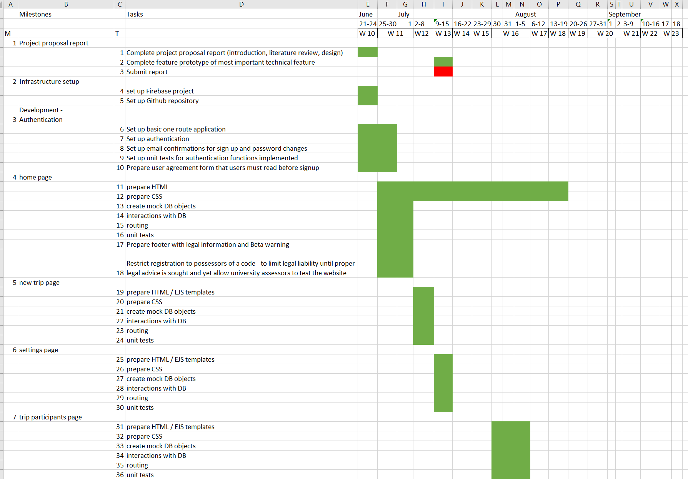

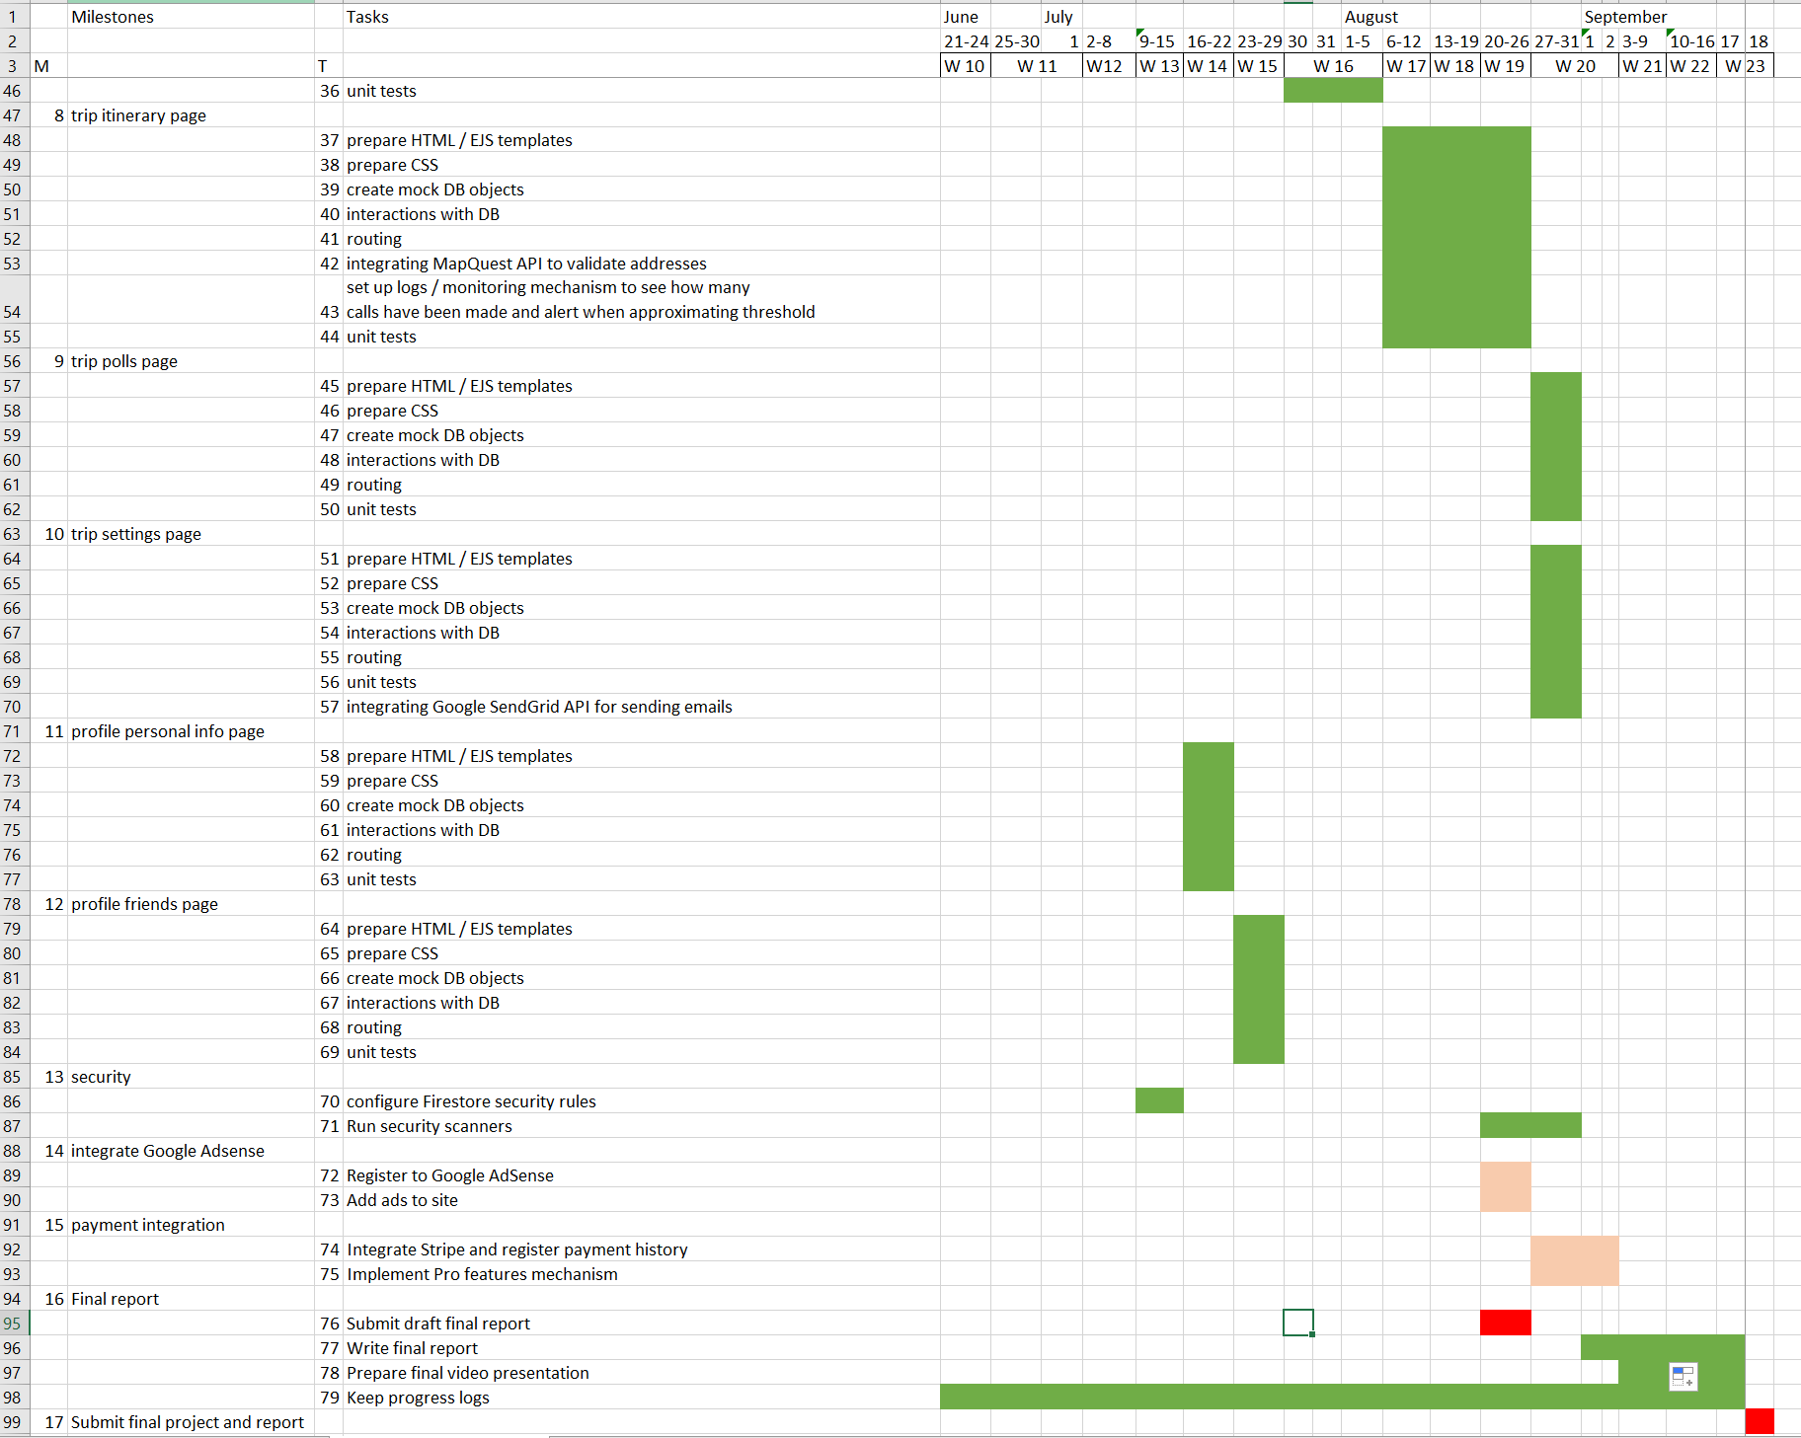

## Appendix M – SEO techniques

|  |  |
| --- | --- |
| **Technique** | **Source** |
| Meaningful domain name containing keywords | [73] |
| * Choose keywords to optimize (“plan trips as a group”) * Repeat keywords at the very top of the page * Include keywords at the beginning of titles * One keyword per title * Name images and alt text with keywords | [74] |
| Ensuring all links from my website (backlinks) work | [73] |
| * Avoid duplication of content within my website (use content negotiation) * Write unique titles, descriptions, content, title tags, meta tags, alt text, | [74] |
| * Site needs to load as fast as possible, especially on mobile (using PageSpeed Insights [75])   + Compress images   + Lightweight themes and content | [74] |
| * Use [Google Search console](https://search.google.com/search-console/welcome) [76] | [74] |
| * Optimize for mobile usability | [74] |
| * Each page on the site references all other pages of the site BUT referenced pages must not throw errors ([signal not to crawl pages accessible only when logged in](https://developers.google.com/search/docs/crawling-indexing/qualify-outbound-links#nofollow))   + Keyword rich anchor text   + [Make links crawlable](https://developers.google.com/search/docs/crawling-indexing/links-crawlable#crawlable-links) | [74, 80] |
| * Maximize time on site (see with [Google Analytics](https://analytics.google.com/analytics/web/#/p321723938/reports/intelligenthome))   + Add captivating video at the start   + Make website attractive     - Use infographics     - Animated SVGs   + Add interactive elements | [74, 77] |
| * Get other sites to link your site   + Advertise on social media   + Make website attractive     - Use infographics     - Animated SVGs   + Create content hub: review of all similar sites e.g. on an article or Wikipedia   + Create me vs. competitor articles / keywords   + Create linkable assets   + Look for “best sitest that…” articles and pitch product to include it | [74, 77, 79] |
| * Use <https://www.semrush.com/sensor/> to see topic ranking | [77] |
| * Analyze keywords used by competitors and optimize for those | [78] |

## Appendix N – Feature prototype unit tests

### N.1 package.json configurations



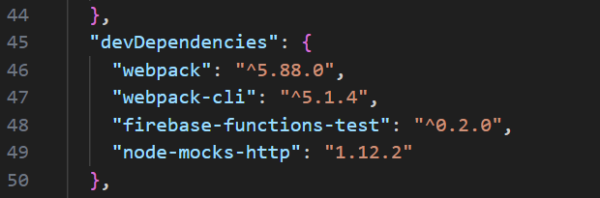

### N.2 – unit tests folders

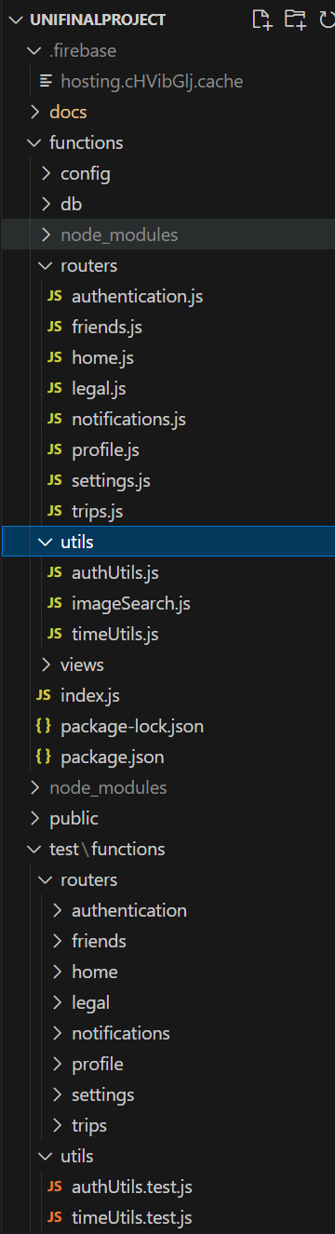

### N.3 – Example unit tests for routes



### N.4 Unit tests results

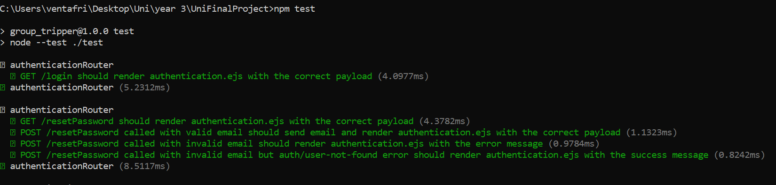

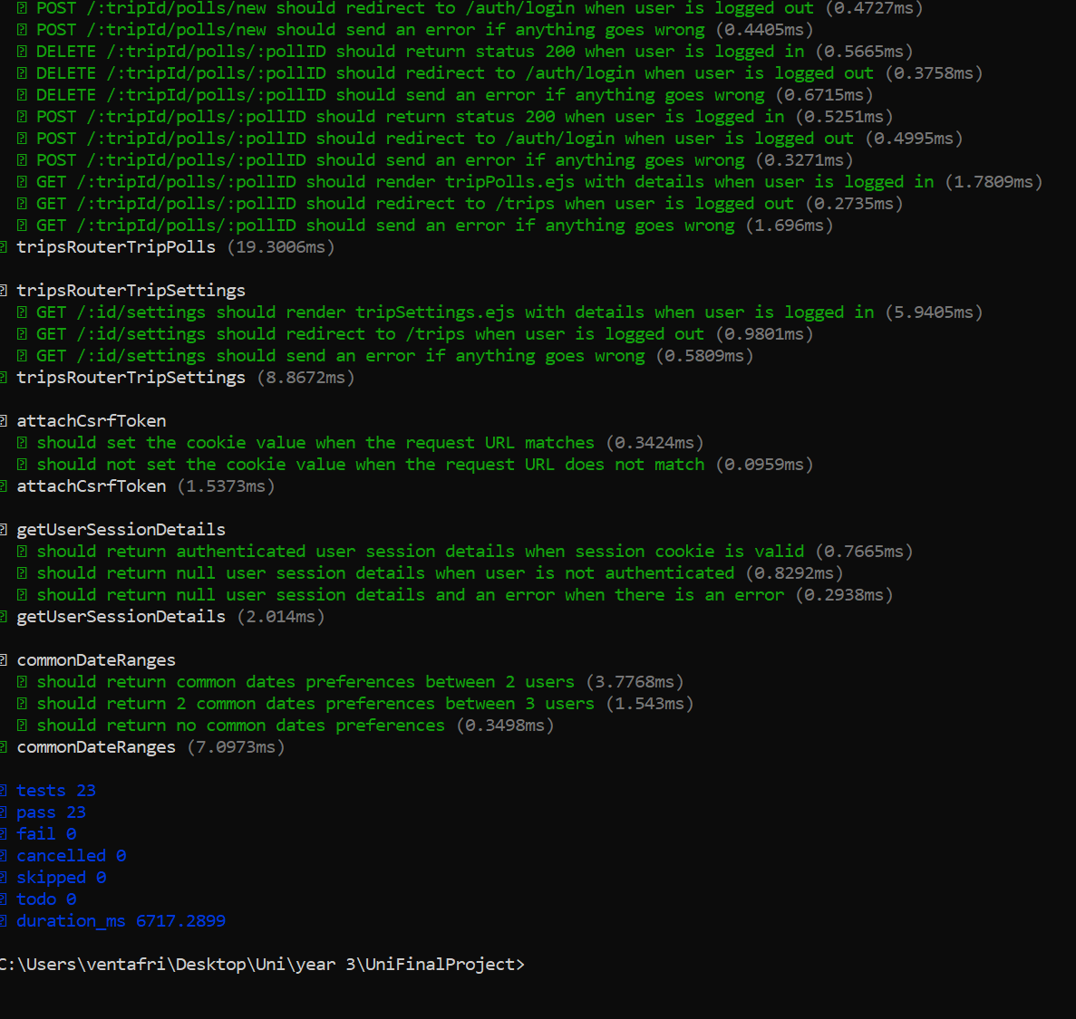

## Appendix O – Feature prototype database interactions

### O.1 – DB class: contains generic methods to interact with Firestore



### O.2 – Sample queries



## Appendix P – Feature prototype input validation and sanitization

### P.1 - Front-end validation



### P.2 – Backend sanitization



## Appendix Q – Authentication

### Q.1 – session creation API end point



### Q.2 – Frontend Login call



## Appendix R – GitHub repository and Git usage

### R.1 - git log



### R.2 – GitHub repository



## Appendix S – Blackbox testing

|  |  |  |  |
| --- | --- | --- | --- |
| **n.** | **Feature** | **Testing procedure** | **Test result** |
| 1 | Experience main functionality without logging in | When users are not logged in, although they can’t directly interact with the actual functionality of the website, they can still see all functionality available and how the website looks like from the home page. Here, a series of gifs demonstrate the typical user flow when organizing a trip. | Pass |
| 2 | User registration | Users can reach the signup page either by clicking on the call for action button visible on the hero image from the home page or by opening the burger menu on the navigation bar (top-right) and clicking on ‘Sign up’. Users then need to enter a code (‘girotondo’) in order to sign up, fill in their username, email address, and password, accept terms and conditions, and then click register . Check emails and click on registration confirmation link. | Pass |
| 3 | User login | Open burger menu from navigation bar. Click ‘Log in’. Enter email and password and then click ‘Log in’. | Pass |
| 4 | Password reset | Open burger menu from navigation bar. Click ‘Log in’. Enter email and password and then click ‘Log in’. Click on ‘forgot password?’ link. Follow instructions received via email and log in again. | Pass |
| 5 | Display clear user agreement and data privacy documentation | Privacy policy and terms and conditions must be accepted when signing up and are always available in the footer of each page. | Pass |
| 6 | Logout | After logging in, can click on navbar burger menu, ‘Log out’. The action redirects home. If I try to access pages that require authentication at this point (<https://grouptripper-3c7f1.web.app/trips> ), I am redirected to <https://grouptripper-3c7f1.web.app/auth/login> | Pass |
| 7 | Delete account | As authenticated user, I can click on the burger menu from the navbar and then on ‘Profile’. I can click on ‘Delete Profile’. A popup alert asks me to confirm and if I click OK, my profile is deleted from the database, I am logged out and redirected home. All trips for which I am owner are deleted. Notifications I have sent are removed from my friends’ profiles. | Pass |
| 8 | Communicating to developers / product owners | On the footer of each page I can see the email address of GroupTripper: contact.grouptripper@gmail.com | Pass |
| 9 | Create a new plan | I am logged in. From the home page (<https://grouptripper-3c7f1.web.app/trips> ) I click on “New trip”. A modal opens. I can specify trip title, the modality of collecting dates (either I decide and just ask the rest of participants to accept or decline, or I can ask everyone to first say when they are available, look for common availabilities and finalized dates when everyone responded), enter my date availability/ies, specify how many working days and total days I am available. When I click ‘Save’, the trip is saved to the database, and the page <https://grouptripper-3c7f1.web.app/trips> refreshes, listing the newly created trip. An image is chosen as cover picture for the trip, based on the trip name. | Pass |
| 10 | Abandon creation of new plan | I am logged in. From the home page (<https://grouptripper-3c7f1.web.app/trips> ) I click on “New trip”. A modal opens. I can close it by clicking on ‘Cancel’. | Pass |
| 11 | Display existing plans on the home page | * I am logged in and visit https://grouptripper-3c7f1.web.app/trips . I can see a card for each trip I have created. If I click on the drop-down menu at the top-left of the page, I can decide to filter upcoming trips, all trips, or past trips. By default only upcoming trips are displayed. | Pass |
| 12 | Delete plans form the home page | * Each plan card visible here <https://grouptripper-3c7f1.web.app/trips> also contains a small delete icon. * When I click on the delete icon, a pop-up window asks me to confirm deletion. * If I click on ‘Yes, delete’, the plan and all its related info are removed from the database. The page reloads and the deleted trip is no longer there. | Pass |
| 13 | View details of existing plan | I am logged in. From <https://grouptripper-3c7f1.web.app/trips> I can click on any trip card and a dedicated page loads, displaying the trip details. | Pass |
| 14 | View/edit participants of plan | I am logged in. I visit [https://grouptripper-3c7f1.web.app/trips/<trip ID> /participants](https://grouptripper-3c7f1.web.app/trips/%3ctrip%20ID%3e%20/participants) following steps of test 13. I click on ‘Add friends’ button in the top-left corner of the participants tab. The required steps to add friends are listed. Step 1) asks to send the sign up link to a friend and ask them to sign up. I will consider this done. Step 2) says: “If you haven’t already, add friends to your profile”. A button is available to perform this operation. I will assume this step is already done as it is described in more details in test 21. Step 3) invites to type friends names into an input element. I click on the input element and automatically a list of available friends is populated and I can add or remove friends I want to add in one operation before saving. The page reloads and the friend/s I added are displayed with status pending in the list of trip participants. | Pass |
| 15 | View / edit itinerary of plan | I am logged in. I visit [https://grouptripper-3c7f1.web.app/trips/<trip ID> /participants](https://grouptripper-3c7f1.web.app/trips/%3ctrip%20ID%3e%20/participants) and by clicking on the ‘Itinerary’ tab I am redirected to [https://grouptripper-3c7f1.web.app/trips/<trip ID> /itinerary](https://grouptripper-3c7f1.web.app/trips/pXHl0yfcSXZ2IUGS9LpB/itinerary) . I see a button on the top-left corner of the tab ‘Add event’. I click on it, a modal opens, and fill the form to create 6 different types of events. I can save the new event by clicking ‘Save’. The page reloads and lists the new event in a card. If I click on the card I can see the event details, modify them and save again. I can also comment on the event. Comments are refreshed immediately on each trip participant’s page (websockets channel is open). | Pass |
| 16 | View / edit polls for the plan | I am logged in. I visit [https://grouptripper-3c7f1.web.app/trips/<trip ID> /participants](https://grouptripper-3c7f1.web.app/trips/%3ctrip%20ID%3e%20/participants) and by clicking on the ‘Itinerary’ tab I am redirected to [https://grouptripper-3c7f1.web.app/trips/<trip ID> /polls](https://grouptripper-3c7f1.web.app/trips/%3ctrip%20ID%3e%20/polls) . I can click on the ‘New Poll’ button on the top-left corner of the tab and a modal opens, allowing me to create a poll by typing a questions, 2/more answers, deciding how many answers participants can choose. By clicking on the ‘Save’ button, the page refreshes and I can see the new poll listed on the page. Once the poll is created, all poll participants receive a notification in real time. The notification asks to reply to the poll. By clicking on it, participants can register their answer/s into the database. Each poll card displays a button to see poll results, a button to edit the poll (only available to the poll owner), and a button to comment on the poll. Comments are written and read in real-time from the database via a Websocket channel opened with the Firebase DB. | Pass |
| 17 | delete plan from plan details | I am logged in. I visit [https://grouptripper-3c7f1.web.app/trips/<trip ID> /participants](https://grouptripper-3c7f1.web.app/trips/%3ctrip%20ID%3e%20/participants) and by clicking on the ‘Settings’ tab I am redirected to [https://grouptripper-3c7f1.web.app/trips/<trip ID> /settings](https://grouptripper-3c7f1.web.app/trips/%3ctrip%20ID%3e%20/settings) . By clicking on it, plan owners can see a button to delete the trip (‘Delete trip’). When clicking on it a pop up alert is displayed. If I confirm, the trip is deleted from the database. All related information is deleted (notifications, clean up trip participants’ records). | Pass |
| 18 | Remove myself from plan | I am logged in. I visit [https://grouptripper-3c7f1.web.app/trips/<trip ID> /participants](https://grouptripper-3c7f1.web.app/trips/%3ctrip%20ID%3e%20/participants). I can click on button ‘Abandon trip’ available in the first card on the page. If there are other participants in the trip and I am the owner, I am prompted to remove them first. Otherwise, I can confirm and remove myself from the trip. If I am the owner, the trips is deleted, otherwise not. The DB is cleaned up by removing all information related to this trip if the trip is removed. | Pass |
| 19 | Edit trip name | I am logged in. I visit [https://grouptripper-3c7f1.web.app/trips/<trip ID> /participants](https://grouptripper-3c7f1.web.app/trips/%3ctrip%20ID%3e%20/participants). At the top of the page, on the hero image, I can click on the pencil icon and modify the name of the trip. Then I can save it by clicking on the save icon. This operation is available from all trip tabs. | Pass |
| 20 | View / edit personal info | I am logged in. I click on the navbar burger menu, ‘Profile’. I am redirected to [https://grouptripper-3c7f1.web.app/profile/<user id>](https://grouptripper-3c7f1.web.app/profile/%3cuser%20id%3e) . From here, I can both change my profile picture and change my username.  When I click on ‘Edit picture’, a modal opens, in which through a button I can select an image from local storage, resize it and center it. I can save the new image by clicking on ‘Save’ or cancel the operation.  To change my username I can click on the pencil icon next to it. This changes the username to editable input box and replaces the pencil icon with a save button. An alert message confirms the success or failure of the operation. | Pass |
| 21 | View / edit friends | I am logged in. I click on the navbar burger menu, ‘Profile’. I am redirected to [https://grouptripper-3c7f1.web.app/profile/<user id>](https://grouptripper-3c7f1.web.app/profile/%3cuser%20id%3e) . From here, I can click on the ‘Friends’ tab. From the search bar I can look for an exact match for a username or email address registered in the database. If no results are found, a corresponding message is displayed. Is a result is found, it is returned with a corresponding available action (none if user is myself, none if user is already friend, ‘add’ if I can add to friends. When I click the add button, a notification is immediately sent to the target user. They can accept or refuse my friendship request and as soon as they do, I am in turn notified. Once two users are friends, any of them can remove the other from their friends. The other user is notified. On this tab I can see my list of friends, divided by accepted and pending. | Pass |
| 22 | Change language | The system must allow users to specify the language they prefer in a visible position on the navbar.  The system must translate all content upon selection of a language | Not implemented – outside scope of MVP’s acceptance criteria |
| 23 | Map view | The system must display a map with pins for each location listed as a desired itinerary | Not implemented – outside scope of MVP’s acceptance criteria |
| 24 | Allow to make plans public | * The system must allow users to make their plans public * The system must allow users to browse existing public plans filtering by location and days * The system must allow to copy an existing template to new and edit it | Not implemented – outside scope of MVP’s acceptance criteria |

## Appendix T – Security scan results

### T.1 results view – first scan

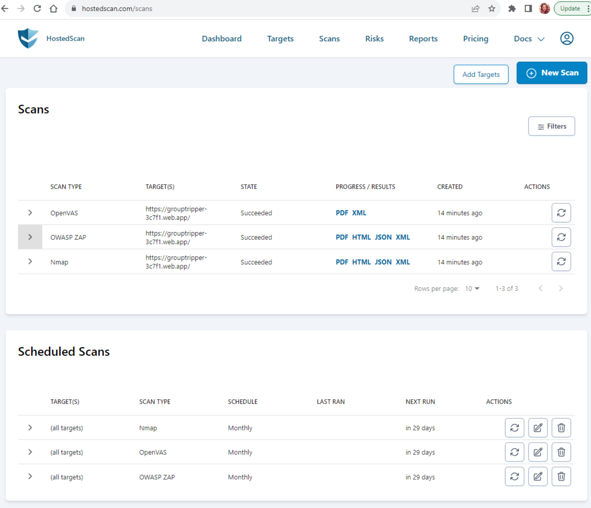

### T.2 OpenVAS– first scan

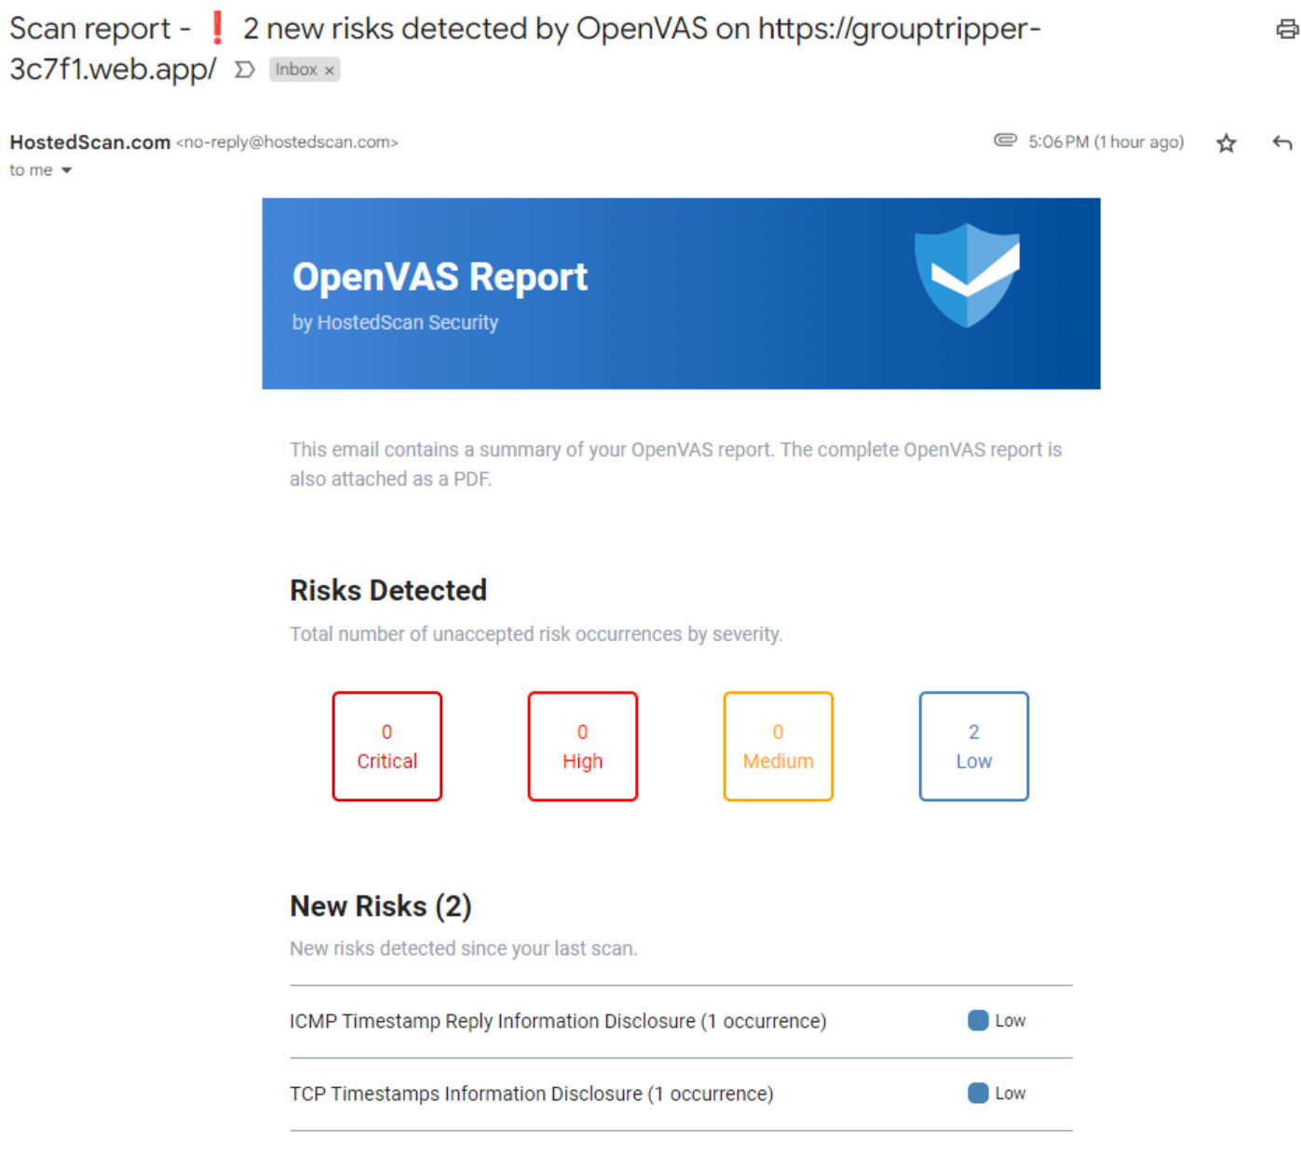

### T.3 Nmap – first scan

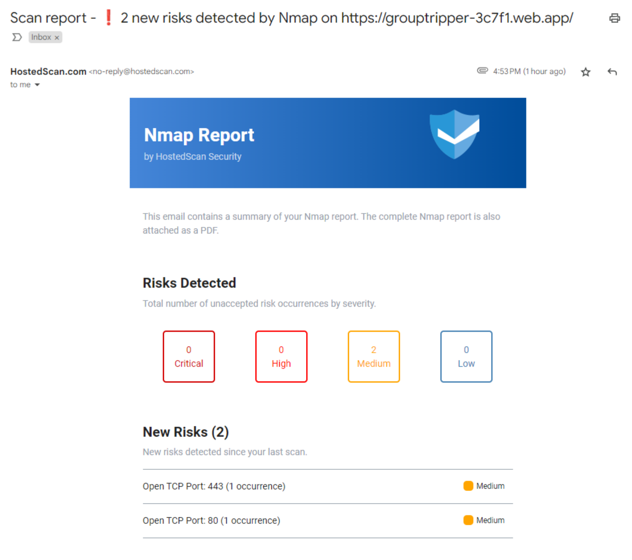

### T.4 OWASP– first scan

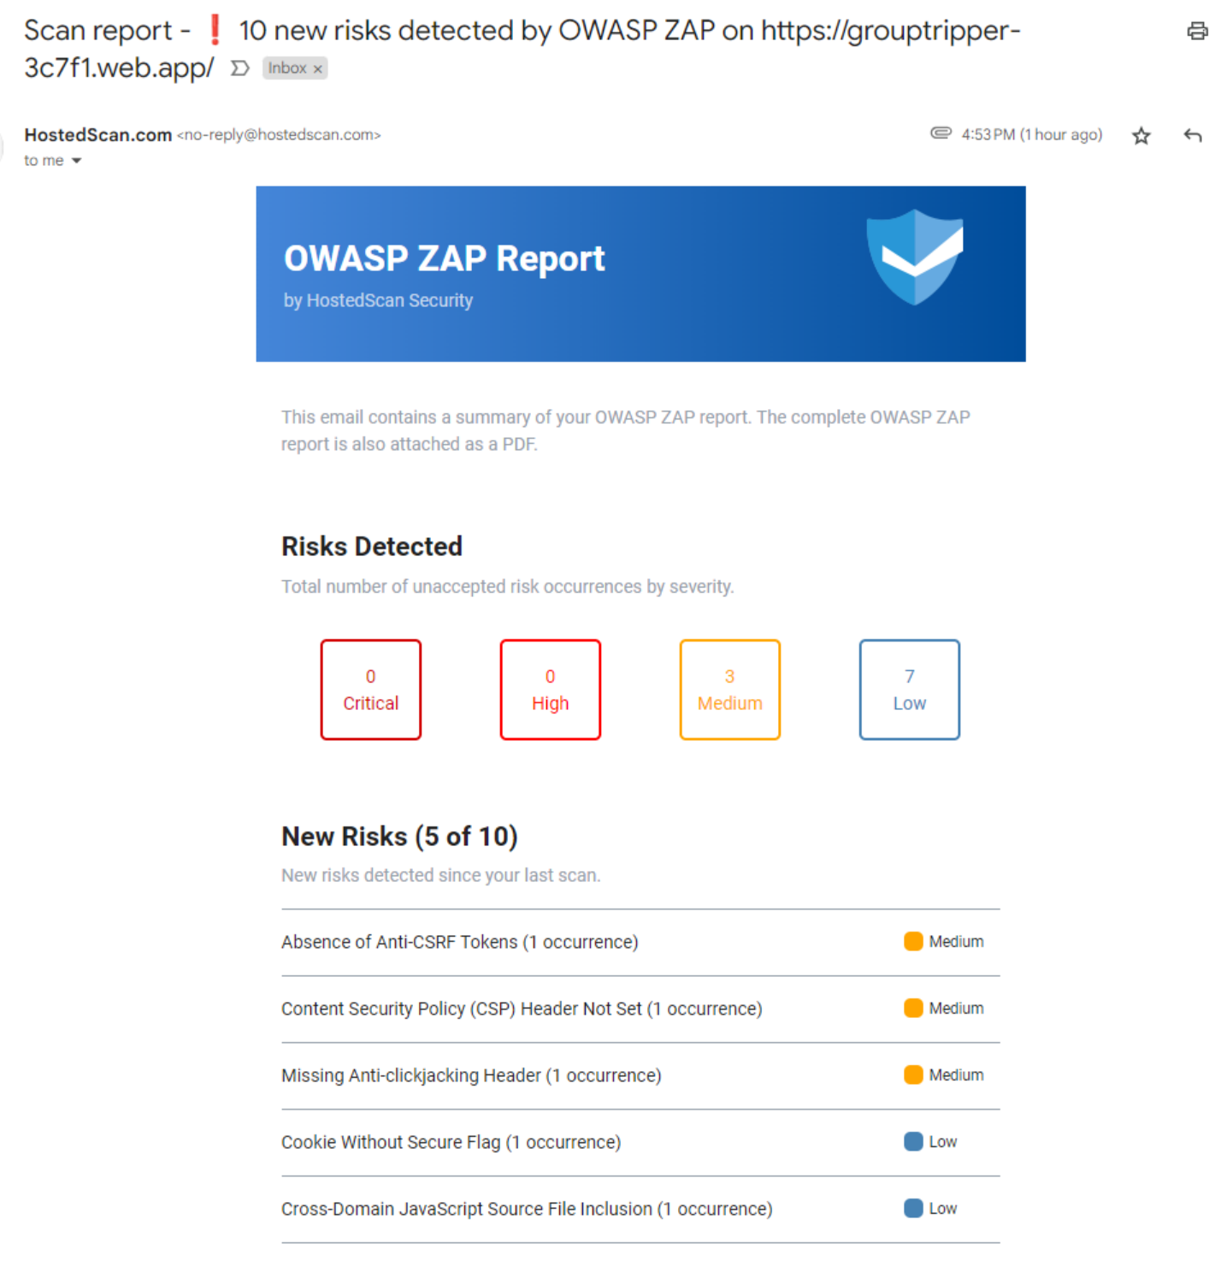

### T.5 – second scan

